Date of publication xxxx 00, 0000, date of current version xxxx 00, 0000.
Digital Object Identifier 10.1109/ACCESS.2024.Doi Number
Design and Simulation of a Broadband, Low-loss, Tunable Transmittance Optical Filter Using Sb₂Se₃ Phase Change Material
CHETTANAT PADUNGATTHAKIJ¹, SURAWUT WICHARN^{2,*}, (Member, IEEE),
SUEBTARKUL SUCHAT³, AND PRATHAN BURANASIRI^{1,4}
¹Artificial Intelligence Photonics Advanced Research Laboratory, Department of Physics, School of Science, King Mongkut’s Institute of Technology Ladkrabang, Bangkok 10520 Thailand
²Department of Physics, Faculty of Science, Srinakharinwirot University, Bangkok 10110 Thailand
³Department of Physics, Faculty of Science and Technology, Phranakhon Rajabhat University, Bangkok 10220 Thailand
⁴Electronic and Optoelectronic Device Research Unit, School of Science, King Mongkut’s Institute of Technology Ladkrabang, Bangkok 10520 Thailand
Corresponding author: Surawut Wicharn (surawutw@g.swu.ac.th).
This work was supported in part by the funding from School of Science, KMITL (CN-1-2568-010).
ABSTRACT We propose transmittance-amplitude filters based on antimony triselenide (Sb₂Se₃) that operate around 1064 nm wavelengths. Sb₂Se₃ is a phase change material (PCM) that has low absorption in the infrared spectrum, large and stable refractive index contrast between phases, and high optical endurance. Existing PCM-based near-infrared filters have high absorption which results in low transmission efficiency. We provide the reasoning for selecting long-pass edge-filter design and compare its performance to other planar thin-film designs and similar optical devices using transfer matrix method simulations. At 1064 nm, the proposed five-unit-cell edge-filter design has 93.6% transmittance in amorphous and 0.2% in crystalline phase, a 93.4% contrast with ~200 nm FWHM. The design shows minimal optical degradation after simulating 1.5×10⁶ phase switching cycles. We show the transmittance amplitude of the design can be tuned in a step from peak 93% to 0% by changing the phase of each Sb₂Se₃ layer. The thickness in each layer can be optimized to increase the transmittance contrast across 1000–1200 nm.
INDEX TERMS Antimony triselenide, Optical designs, Optical filters, Phase change materials, Thin films
- INTRODUCTION
The term phase change material (PCM) can have different meanings depending on the research field. In energy storage, the term refers to materials that can store and release their thermal energy through changes in their state of matter, e.g. from solid to liquid state [1]. However, in the fields of electronics and photonics, the term refers to a solid-state material that changes its crystal structure depending on the temperature, such as transitioning from an amorphous to a crystalline phase when the temperature rises above transition temperature, T_{trans}. This change leads to a high contrast in complex refractive index ñ between the initial and post-transitioned phases, where ñ = n + ik comprises the real refractive index n and the imaginary extinction coefficient k [2]. The refractive index contrast is an order of magnitude larger than the contrast from applied electric field or Kerr effect (light intensity) [3], this property makes PCMs ideal for photonic applications that require the modulation of optical performance. Some examples are reconfigurable metasurfaces [2, 4-6], optical limiters [3, 7-11], optical switches [12-14], optical filters [15-18], and absorbers [19, 20].
PCM can be classified according to its post-transition behavior. It is considered a volatile PCM if the phase reverts to pre-transition phase when the temperature falls below T_{trans}. It is considered a non-volatile PCM if it maintains its post-transition phase even when temperature falls below T_{trans}. One of the most common volatile PCMs is vanadium dioxide (VO₂), it undergoes metal-to-insulator transition (MIT) at 68 °C, the lowest among any PCMs. VO₂ has a relatively large complex refractive index contrast (Δn) in the near-IR and IR spectra [21], but its biggest downside is the large absorption due to high extinction coefficients in both phases. Common non-volatile PCMs are chalcogenide glasses called Ge₂Sb₂Te₅ (GST) and Ge₂Sb₂Se₄Te (GSST). GST is one of the earliest and most studied PCMs [22], it has large refractive index contrast between amorphous and crystalline phases, relatively low T_{trans} at ~145 °C when compared to other non-volatile PCMs [3, 23]. Meanwhile GSST has lower extinction coefficients than either GST or VO₂. But it has higher T_{trans} at ~242 °C, and the Δn is also lower [23].
With that being said, antimony triselenide (Sb₂Se₃) is a non-volatile PCM which originated from solar-energy applications, but there is very little research on it in the field of photonics. Sb₂Se₃ unique properties are its near-zero extinction coefficients in near IR and IR spectra, which result in low absorption. Sb₂Se₃ has high and stable refractive index contrast, and very high phase switching endurance in an order of 10⁶—10⁷ cycles [24, 25]. Its transition temperature is between GST and GSST, at ~186 °C [24, 26]. These properties make Sb₂Se₃ an attractive PCM for low-loss, reconfigurable devices used as optical switches or programmable circuits in optical waveguides [4-6, 13, 16, 22, 27]. However, Sb₂Se₃ usage in free-space tunable-transmittance filter has not been explored much [17].
Although PCM-based switchable filter is not a new research topic, the transmission of existing designs is already high in ON mode (transmitted state) and low in OFF mode (reflected/absorbed state), which create a high transmission contrast. However, ON mode performance suffers owing to the existence of extinction coefficients in conventional PCMs [15, 28]. Existing Sb₂Se₃-based filters are on-chip waveguide-based or metasurface structures [5, 14, 29]. While these designs have excellent transmission properties due to high design flexibility, they require complex fabrication processes. A planar thin-film filter is easier to design and fabricate. However, the only existing thin-film Sb₂Se₃-based filter we could find is [17]; their design is a Fabry–Pérot resonant cavity that requires Ag mirrors. FP design has high transmittance contrast but suffers from narrow high-contrast region, and Ag has large extinction coefficient in IR spectrum which create high optical loss. Therefore, a research gap exists for PCM-based, planar thin-film filter with high transmittance contrast and low absorption in ON mode.
In this work, we investigate Sb₂Se₃ as PCM in planar thin-film designs using transfer matrix method simulation. The goal is to design a low-loss, broadband, transmittance-amplitude tunable optical filter centered around 1064 nm. We select this wavelength since it is from ND:YAG laser, commonly used in laboratory setup (1064 nm) and should make the transition to experimental validation easy. The design process is shown starting from simple, one-layer antireflection thin-film to multilayer, long-pass edge-filter film. This design approach can also be used for other filtering application in NIR wavelengths, e.g. night-vision camera [15], gas imaging [17], optical coherence tomography [28].

THEORIES
- OPTICAL PROPERTIES OF ANTIMONY TRISELENIDE
Antimony triselenide (Sb₂Se₃) is an orthorhombic chalcogenide non-volatile phase change material (PCM) characterized by quasi-one-dimensional ribbons. While its amorphous phase consists of a disordered network of distorted motifs, crystallization restores long-range order along the ribbon direction. This thermally driven transition can be triggered by nanosecond to microsecond optical or electrical pulses [22, 24]. The process is reversible and has high endurance, with optical switching reaching 10⁶ to 10⁷ cycles [24, 25]. As an optical device, Sb₂Se₃ enables repeatable toggling between high and low transmission modes, provided that local heating remains below the melting or ablation threshold [4, 25].
The complex refractive index ñ of any phase change material at wavelength λ is:
${\tilde{n}}_{p}\left(λ\right)=n_{p}\left(λ\right)+ik_{p}\left(λ\right)$ (1)
where p denotes the phase of Sb₂Se₃ which can be either amorphous (amo) or crystalline (cry) phase. Dispersive models, such as Tauc-Lorentz or multi-oscillator fits are often used to represent the measured n_{p} and k_{p} over the spectral range of interest. However, in this work, linear interpolation is used because all the datasets used have measurement interval of less than 4 nm. Figure 1 shows their complex refractive indices from 300 to 1700 nm using the dataset from Delaney, et al. [22], where the complex refractive indices at 1064 nm are ñ_{amo} = 3.370 + 0.000i and ñ_{cry} = 4.308 + 0.010i. The blue lines represent real refractive index (n) and the red lines represent imaginary extinction coefficient (k). In amorphous phase, the refractive index increases from ~2.4 at 300 nm to a peak of ~4.0 at 600 nm and gradually decreases to a stable value of ~3.3 above 1200 nm, indicating a strong dispersion near the band edge of visible spectrum and a weaker dispersion in the NIR spectrum. The extinction coefficient starts from ~2.1 at 300 nm and drops to zero at ~850 nm. In the crystalline phase, the refractive index at the UV wavelengths is around the same value as the amorphous phase but reaches a higher peak of ~5.1 at around 660 nm; it then drops to a stable value of ~4.1 in the NIR spectrum. The absorption index of crystalline phase peaks at ~3.1 in the near-UV spectrum and rapidly approaches zero above 900 nm.
The refractive index contrasts (Δn = n_{c} - n_{a}) are large and stable from the visible through IR spectra, and the extinction coefficients are large in the near-UV region but fall to zero around the NIR spectrum for both phases, with the crystalline phase exhibiting higher absorption in the visible spectrum. Thus, when compared to other PCMs, Sb₂Se₃ has several advantages when operating in the NIR and IR wavelengths. The large Δn and low k starting from NIR wavelengths enable a device to operate in two modes with little to no optical loss, and a stable Δn also helps with broadband designs.
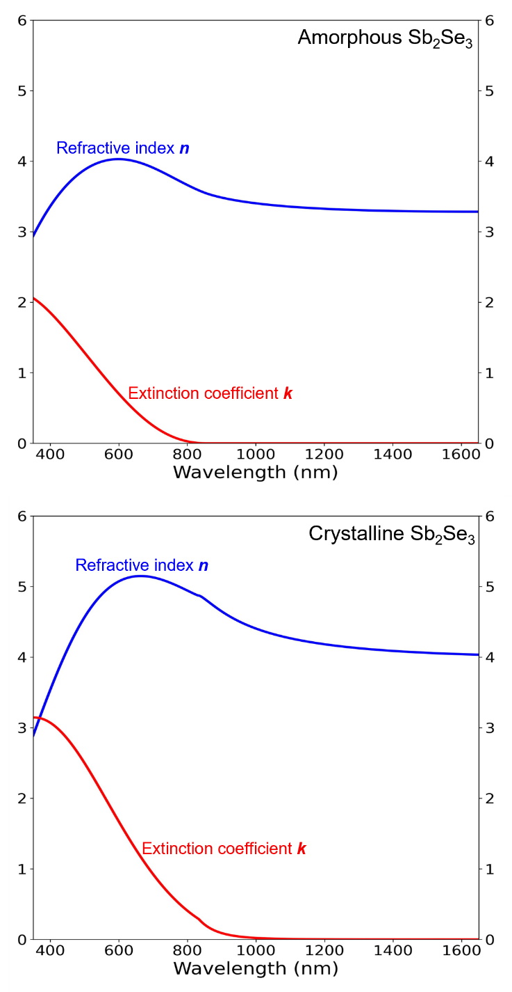
Complex refractive index of Sb₂Se₃. Graphs are plotted from experimental data of [22].

- SINGLE-LAYER ANTIREFLECTION DESIGN
The goal of designing most optical devices is to either create antireflection or high-reflection conditions. For a two-mode optical device, such as a transmittance amplitude tunable filter, we can consider the reflection in the ON mode first, and then the reflectance contrast ΔR between the ON and OFF modes. The simplest antireflection from a planar thin-film design is one film layer deposited on top of a substrate; both the film and the substrate should have zero absorption. The diagram in the top right corner of Fig. 2 shows that a single-layer film reflects light at two interfaces: the bottom interface between the film and substrate (R₁) and the top interface between the air and film (R₂). Antireflection occurs from the destructive interference between R₁ and R₂, with a complete AR condition requiring the same amplitude and a phase difference of π radian (optical path length of λ/2). Because R₁ propagates through the thin film layer twice (while transmitted down and reflected backup), the optical thickness (OT) of the film only needs to be equal to half of the optical path length, OT = λ/4, this also known as quarter-wave optical thickness (QWOT). The optical thickness is related to the physical thickness t by the following equation:
$OT(λ)=n(λ) t$, (2)
where n(λ) is the refractive index of the film at λ. For a single-layer AR device, the thin-film physical thickness t must be
$t=\frac{OT}{n}=\frac{λ/4}{n}$. (3)
Another method for calculating the thickness required for the AR condition is to consider the reflection of the device. The reflectance R of only the substrate is related to the Fresnel coefficient r by
$R= {\left|r\right|}^{2}={\left|\frac{n_{a}-n_{s}}{n_{a}+n_{s}}\right|}^{2}$, (4)
where n_{a} is the air refractive index, and n_{s} is the refractive index of substrate. If a single-layer film is placed on top of a substrate, the film and substrate layers can be combined into an effective reflectance index n_{r} [30], defined as
$n_{r}=n_{f}\frac{\left(n_{s}+n_{f}\right)+\left(n_{s}-n_{f}\right)e^{-i2θ}}{\left(n_{s}+n_{f}\right)-\left(n_{s}-n_{f}\right)e^{-i2θ}}$, (5)
where n_{f} is the film refractive index, i is the imaginary unit, and θ is the phase thickness which is related to optical thickness and physical thickness t by the angular wavenumber k₀ = 2π/λ:
$θ=k_{0}OT=k_{0}nt$. (6)
By replacing n_{s} in Eq. 4 with n_{r} from Eq. 5, the reflectance of a single-layer device becomes:
$R={{\left|r\right|}^{2}=\left|\frac{n_{a}-n_{r}}{n_{a}+n_{r}}\right|}^{2}$. (7)
Antireflection happens when R = 0 or n_{r} = n_{a}. This condition occurs when the phase thickness θ is in multiple of π/2 radians:
$θ=Z\frac{π}{2}$, (8)
where Z denotes even integer. If this condition is satisfied, Eq. 5 can be simplified with Euler’s identity (exp^{-iπ} = -1) to:
$n_{r}=n_{f}\frac{\left(n_{s}+n_{f}\right)-\left(n_{s}-n_{f}\right)}{\left(n_{s}+n_{f}\right)+\left(n_{s}-n_{f}\right)}=\frac{n_{f}^{2}}{n_{s}}$. (9)
By substituting this into Eq. 7, the refractive indices for antireflection condition becomes:
$n_{a}n_{s}=n_{f}^{2}$ (10)

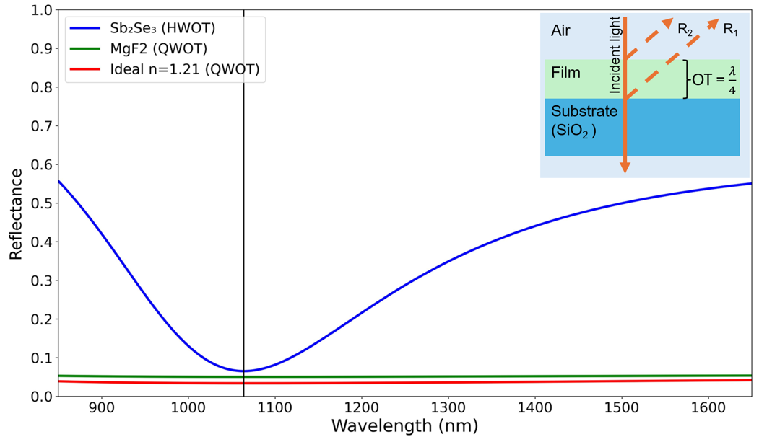
The reflectance of a single-layer design with different refractive index and thickness, the black vertical line indicates 1064 nm. At this wavelength, HWOT-thick Sb₂Se₃ (blue) has the highest reflection R = 6.5%. QWOT-thick MgF₂ (green) R = 5.0%. An ideal QWOT-thick film with n_{ideal} = 1.21 (red) has the lowest reflectance, R = 3.4%. Cross-section diagram of the QWOT-thick structure is shown in the top-right corner.

Another condition is the relative refractive index between the air, film, and substrate, which must be in the following order: n_{air} < n_{f} < n_{substrate}. Light shifts its phase by π radian when reflected from a lower to a higher refractive index medium. The reflected light at the air-film interface (R₂) will always undergo a π radian phase shift since n_{a} will be the lowest in most cases. Therefore, R₁ must undergo the same phase shift to create destructive interference.
These two conditions limit material selections for a perfect antireflection, since there is only one ideal refractive index (n_{ideal}) for each n_{s}. The refractive index of Sb₂Se₃ is higher than that of substrate (silica; SiO₂) at every wavelength. So, if Sb₂Se₃ is QWOT, the reflection from R₁ still travels 2QWOT (π radian) further than R₂ but only R₂ has its phase shifted by π radian during reflection, so the two R’s have a phase difference of 0 radian, a constructive interference. To minimize reflection, the Sb₂Se₃ thickness can be increased to twice the QWOT (OT = λ/2), this is called half-wave optical thickness (HWOT) and is equivalent to an absentee layer. For example, at the reference wavelength λ₀ = 1064 nm, if we use 3-mm-thick SiO₂ as the substrate (n_{s} = 1.46) [31], the ideal QWOT-film thickness is calculated from Eq.10 to be n_{ideal} = 1.21. The material with the closest refractive index is MgF₂ (n_{MgF2} = 1.38) [32]. A slight difference from ideal value causes the reflection to be slightly higher, as illustrated in Fig. 2. The reflectance of the Sb₂Se₃ (blue) is the highest, at 6.5%, because the PCM layer is an absentee layer, so the reflection is equivalent to a standalone 3-mm SiO₂ substrate. An ideal film (red) still exhibits small reflectance because of the reflection in the substrate-air layer in the back.

- MULTILAYER ANTIREFLECTION DESIGN
A two-layer design with each layer thickness being QWOT (Q/Q design) can also be used to create antireflection conditions. The Fresnel reflection coefficient r from Eq. 7 can be expanded to
$r=\frac{n_{a}-n_{r2}}{n_{a}+n_{r2}}=\frac{n_{a}-(\frac{n_{f2}^{2}}{n_{r1}})}{n_{a}+(\frac{n_{f2}^{2}}{n_{r1}})}=\frac{n_{a}-(\frac{n_{f2}^{2}}{n_{f1}^{2}/n_{s}})}{n_{a}+(\frac{n_{f2}^{2}}{n_{f1}^{2}/n_{s}})}$, (11)
where n_{f} begins from the substrate side and increases toward the air side (n_{s} / n_{f1} / n_{f2} / n_{a}), n_{r2} is the effective reflectance index of the entire structure [30], and n_{r1} is the effective reflectance index of only the substrate (n_{s}) and bottom film (n_{f1}). Similar to Eq. 7, the antireflection condition of the two-layer design occurs when n_{a} = n_{r2} or
$n_{a}=\frac{n_{f2}^{2}}{n_{f1}^{2}/n_{s}}$, (12)
$\frac{n_{a}}{n_{s}}=\frac{n_{f2}^{2}}{n_{f1}^{2}}$. (13)

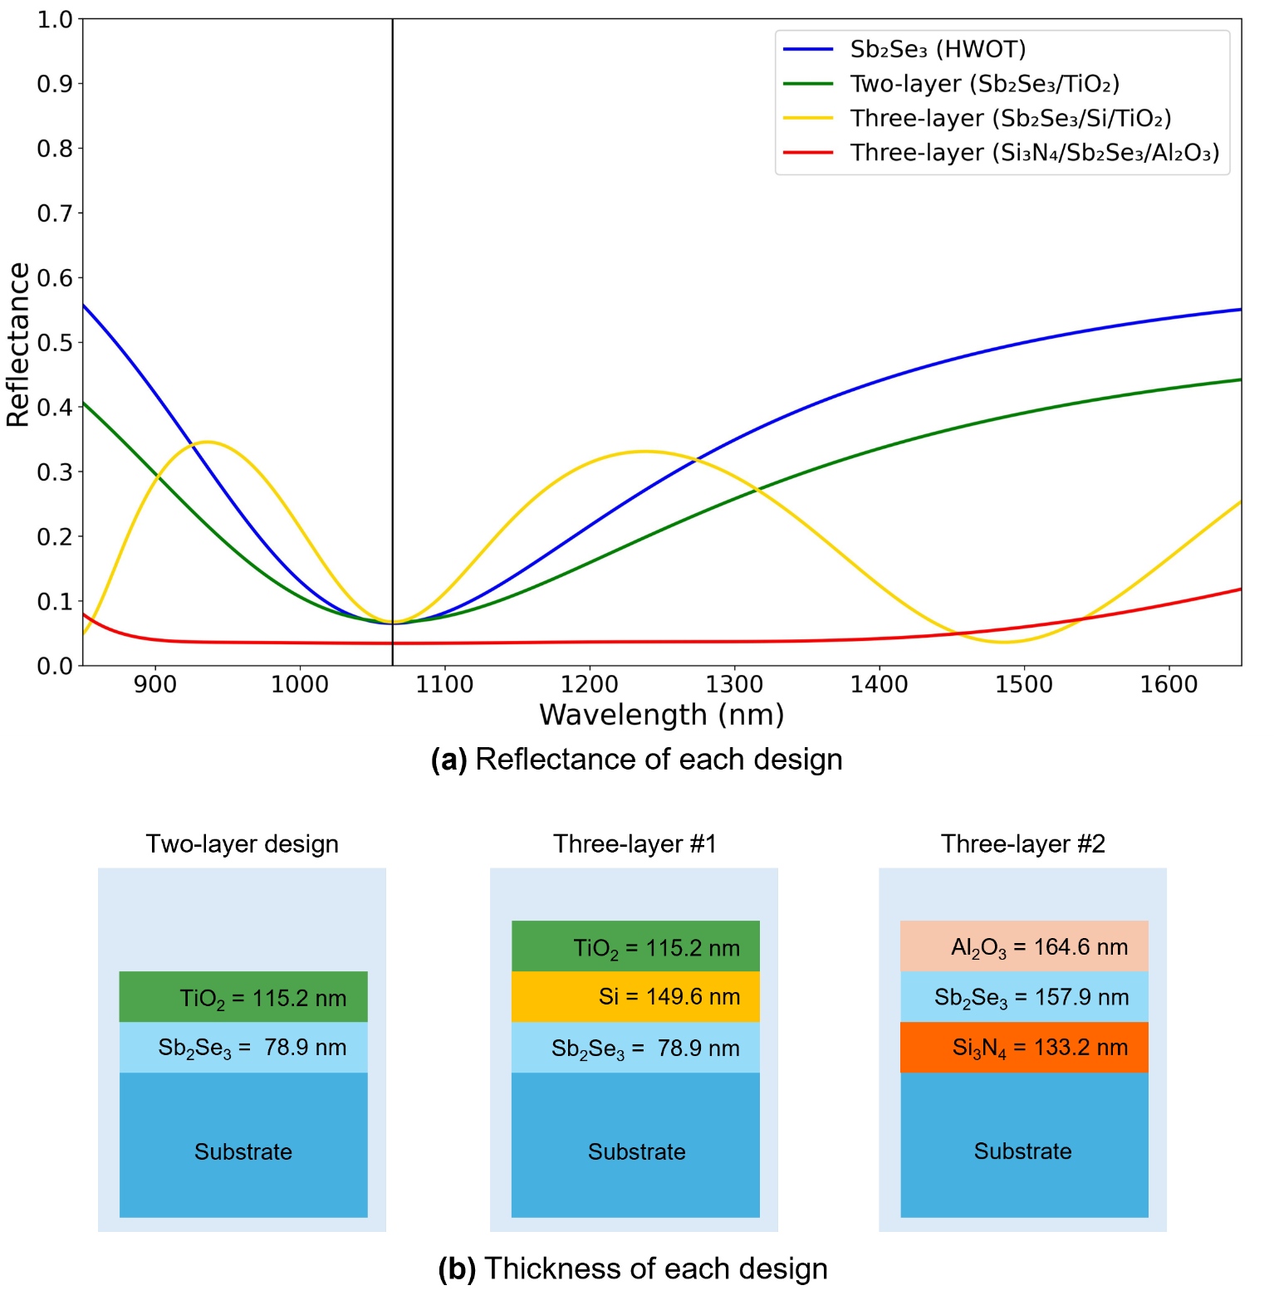
(a) The reflectance profiles of four different designs. The single-layer, two-layer, and three-layer design with Sb₂Se₃ at the bottom have around the R = 6.5–6.7%. However, the three-layer design with Sb₂Se₃ as middle layer has refractive index ratio of n_{f1} and n_{f2} closer to ideal values, so its reflectance value is the lowest at R = 3.4%. (b) Cross-section diagrams showing each layer thickness.

From Eq. 13, it can be seen that the refractive index of the top film must be smaller than the bottom film (n_{f2} < n_{f1}). For example, at λ₀ = 1064 nm, if we use the same SiO₂ as substrate (n_{s} = 1.46) and Sb₂Se₃ as the bottom film (n_{f1} = 3.37), the ideal refractive index of the top film (n_{f2}) is 2.78. A commonly used material with the closest refractive index is TiO₂ (n_{TiO2} = 2.31) [33]. Compared to the single-layer Sb₂Se₃ design, the two-layer Sb₂Se₃/TiO₂ design has a lower reflectance at 1064 nm and wider AR region, as shown in Fig. 3. Another way to create a two-layer AR condition is to fix the two film refractive indices and vary the thickness of each film, as explained in Chapter 5.2 of [30]. However, this method narrows the spectral range of the antireflection region.
A three-layer design with an HWOT-thick film in the middle (Q/H/Q) requires refractive index orderings of n_{s} < n_{f1} < n_{f2} and n_{f2} > n_{f3} > n_{a} for antireflection properties. The middle layer (n_{f2}) acts as an absentee layer when the incident wavelength is the same as the reference wavelength (λ = λ₀). The reflection coefficient is equal to
$r=\frac{n_{a}-n_{r3}}{n_{a}+n_{r3}}=\frac{n_{a}-\left(\frac{n_{f3}^{2}}{n_{r2}}\right)}{n_{a}+\left(\frac{n_{f3}^{2}}{n_{r2}}\right)}=\frac{n_{a}-\left(\frac{n_{f3}^{2}}{n_{f1}^{2}/n_{s}}\right)}{n_{a}+\left(\frac{n_{f3}^{2}}{n_{f1}^{2}/n_{s}}\right)}$. (14)
Because the middle film layer (n_{f2}) is HWOT thick, it behaves as an absentee layer [30, 34]. So n_{r2} = n_{r1} = $n_{f1}^{2}/n_{s}$. A three-layer antireflection condition occurs when
$\frac{n_{a}}{n_{s}}=\frac{n_{f3}^{2}}{n_{f1}^{2}}$. (15)
The refractive index ratio of top and bottom films is similar to that of the two-layer design. As an example, if the bottom layer (n_{f1}) is Sb₂Se₃ (QWOT), then the ideal top layer (n_{f3, ideal}) is 2.78, so TiO₂ (n_{TiO2} = 2.31) is used again. The middle layer needs to have the highest refractive index, so Silicon (Si) is used (n_{Si} = n_{f2} = 3.55) [35]. As shown in Fig. 3, the reflectance of the three-layer design (yellow) at wavelengths further from λ₀ (i.e., 1400 nm and longer) is lower than that of a single (blue) or two-layer design (green). This is a benefit of adding an extra absentee layer in the middle, it contributes to a broader operating bandwidth [34].
Instead of placing the PCM as the bottom film layer, Sb₂Se₃ can be moved to the middle so that the selection of ideals n_{f1} and n_{f3} is easier. The bottom layer could be Si₃N₄ (n_{f1} = 2.00) [36] and the ideal top layer calculated using Eq. 15 has n_{f3} = 1.65, which Al₂O₃ has the closest refractive index (n_{Al2O3} = 1.62) [33]. These designs are shown in Fig. 3, where the reflectance of the designs with Sb₂Se₃ deposited directly on top of the substrate, i.e., single-layer, two-layer, and three-layer designs, are ~6.5%. But the three-layer design with Sb₂Se₃ placed in the middle (n_{f2} = Sb₂Se₃) has a reflectance of 3.4%, which is the same value as that of an ideal single-layer design (3.4%). This improvement can be explained by the selection of n_{f1} and n_{f3} which are closer to ideal values.

- LONG-PASS EDGE-FILTER DESIGN
In previous sections, we only consider the reflectance of the design when Sb₂Se₃ is in amorphous phase (ON mode). However, because we want to modulate the performance of our optical filters, the reflectance when Sb₂Se₃ transition to crystalline phase (OFF mode) should also be considered. A high reflectance contrast between crystalline and amorphous phases (ΔR = R_{c} – R_{a}) indicates a good modulation power. The reflectance plots of the four designs from Fig. 3 are shown in Fig. 4. The single-layer design reflectance profile red-shifted for ~250 nm and is the only one that has reflectance contrast higher than 50% (Fig 4a, blue: ΔR=55%). More importantly, the three-layer design with Sb₂Se₃ in the middle, which has the lowest reflectance in amorphous phase (R_{a} = 3.4%), only has R_{c} = 14.8% (Fig 4b, red: ΔR=11.4%).
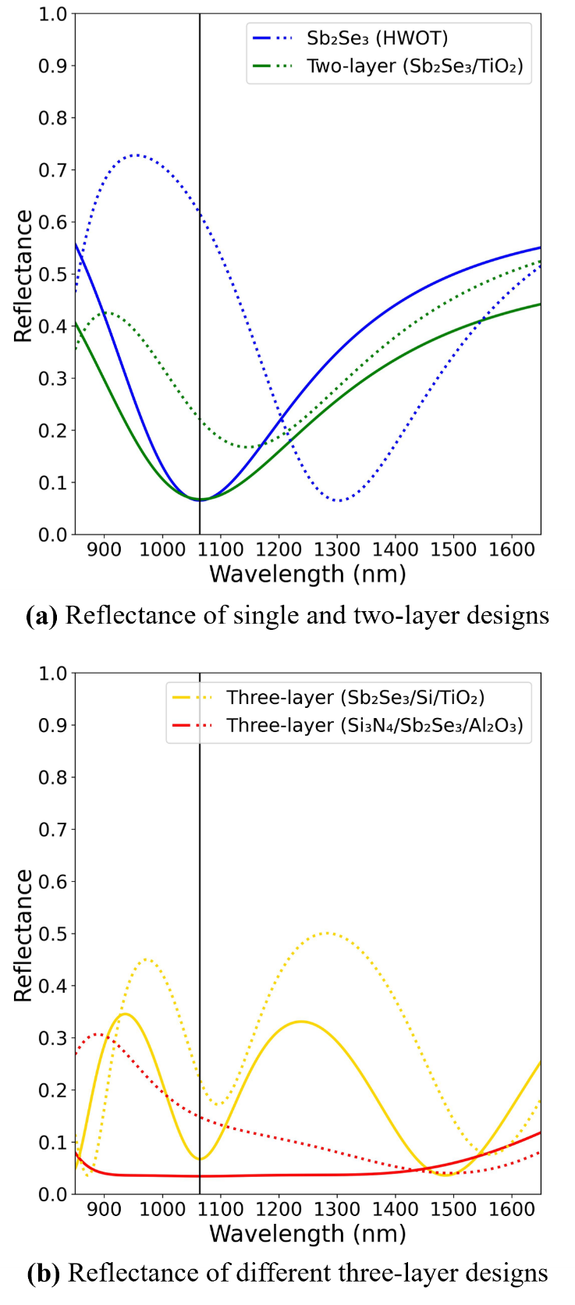
Reflectance of the designs in Fig. 3 before (solid) and after (dotted) phase transition. The single-layer design has the highest reflectance contrast (ΔR = R_{a} – R_{c}) of 55.0%.

So, we need a new structure that has high reflectance contrast but still maintain low reflection in amorphous phase. This introduces us to edge-filter design, the reflectance profile has HR-region centered around the reference wavelength, while the regions outside of this are both AR regions, with a steep spectral edges between the AR- and HR-regions. Edge filter consists of QWOT-thick high-index film (H) and low-index film (L) deposited on top of each other in a structure called unit cell (U), it can either be a long-pass $\left(H/2 L H/2\right)$ or a short-pass design $\left(L/2 H L/2\right)$, the 1/2 symbol denotes half QWOT thickness (OT = λ⁄8). The spectral width of HR-region is directly correlated to the difference between H and L layer’s refractive index, and the number of unit cell directly correlated to the steepness of spectral edge between region. Long-pass design has stable, low reflectance in the longer-wavelength AR region, while short-pass design has the opposite behavior. Long-pass design is selected for this work since it minimize the device thickness.
As an example, Sb₂Se₃ is H layer, and MgF₂ as L layer, the reference wavelength is changed to λ₀ = 740 nm. Figure 5 illustrates the effect the number of unit cell has on the reflectance profile. By increasing the number of unit cell from 1 to 6, the spectral edge is getting steeper. Also, the wavelength of interest (black vertical-line) shifted from AR-region in amorphous phase (Fig. 5a) to HR-region in crystalline phase (Fig 5b), this creates a reflectance contrast higher than single-, double- or three-layer designs previously shown.
The reasoning for selecting λ₀ = 740 nm is shown in Fig. 6. Here, λ₀ are varied from 700–760 nm in the same 4-unit-cell configuration as shown in Fig. 5a (green). At every λ₀, the interested wavelength of 1064 nm is at the edge of AR region (Fig. 6a, solid). So, when Sb₂Se₃ switched to crystalline phase and the reflectance profile redshifted, the interested wavelength is now in high-reflection region (Fig. 6a, dotted). When we look at the reflectance contrast in Fig. 6b, both λ₀ = 740 (green) and λ₀ = 750 nm (yellow) have the same contrast ΔR = 90.6% (Fig. 6b). However, λ₀ is proportional to film thickness, so shorter λ₀ = 740 is used. The cross-sectional view of long-pass and short-pass designs and layer thickness of long-pass design with λ₀ = 740 nm is provided in Fig. 6c. The figures only show 2 unit-cells due to spacing, all long-pass edge-filters in Fig. 6a and Fig. 6b are 4-unit-cell designs

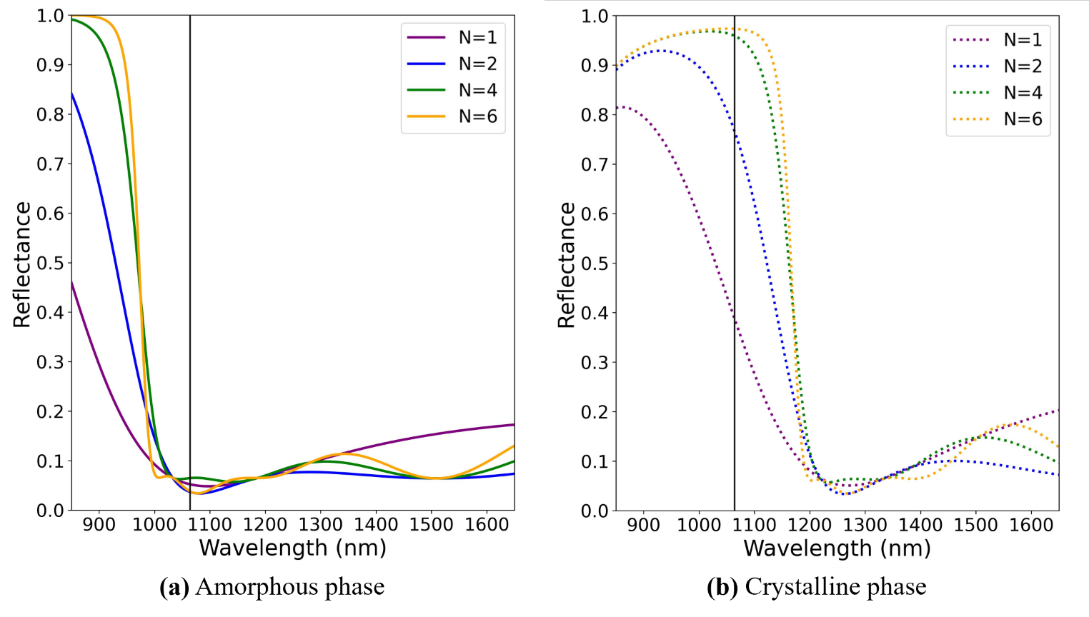
Reflectance profile of long-pass edge-filter designs in each phases. The design used increasing number of unit cell, from 1–6 unit cells. (a) When devices are in amorphous phase (ON mode), the wavelength of interest (black vertical line) is in the AR region. (b) When devices are changed to crystalline phase (OFF mode), the wavelength of interest is in the high-reflection region.

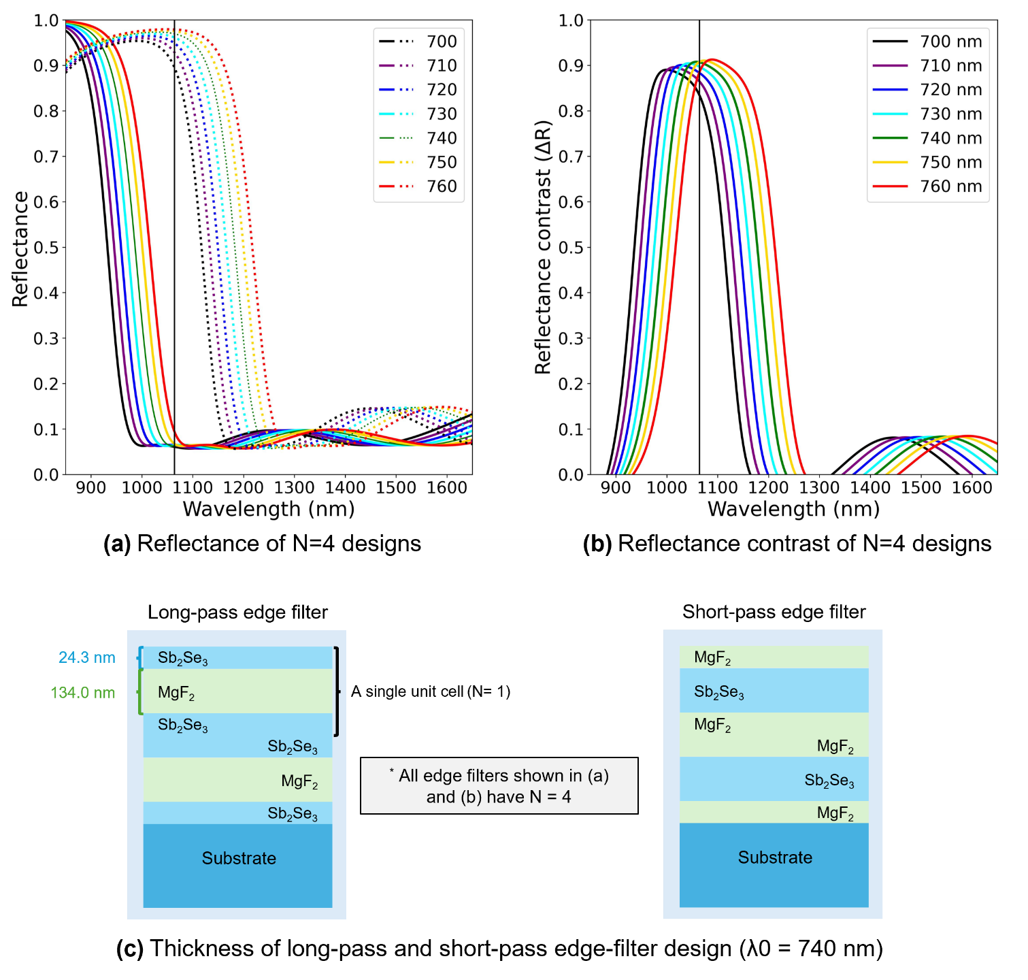
Reflectance profile of long-pass edge-filter designs with reference wavelenght (λ₀) from 700 to 760 nm. (a) Reflectance before (solid) and after (dotted) phase transition shows that increasing λ₀ also increase the spectral profiles. (b) The reflectance contrasts at 1064 nm of λ₀ = 740 and λ₀ = 750 nm are the same ΔR = 90.6%. We select λ₀ = 740 nm for the following design since it allows for slightly thinner device size. (c) Cross-section diagrams showing long-pass and short-pass thickness, λ₀ = 740.

- METHODS
- SIMULATION OF OPTICAL PERFORMANCES
We use transfer matrix method (TMM) of Fresnel equation to calculate the transmittance, absorptance, and reflectance of each design. The computation codes are based on [30], but other simulation software are also applicable. The simulations are going to be from 850–1650 nm at an interval of every 1 nm. The dataset of most element in this work can be found in the website refractiveindex.info [37], with the only exception being Sb₂Se₃ [22]. The high-index layers (H) are silicon with refractive index at 1064 nm equal to n_{Si} = 3.56 [35], titanium dioxide (n_{TiO2} = 2.31) [33], and silicon nitride (n_{Si3N4} = 2.00) [36], while the low-index layers (L) are aluminium oxide (n_{Al2O3} = 1.62) [33], silicon dioxide (n_{SiO2} = 1.47) [31], and magnesium fluoride (n_{MgF2} = 1.38) [32]. The substrate layer has the same refractive index as n_{SiO2} and is 3 mm thick. The reflection from the substrate-air layer on the backside is calculated. Every dataset has a measuring interval of less than 4 nm. The incident angle is 0°, and light polarization mode is transverse electric (TE), unless specifically mentioned.
The performance indicators are going to be transmittance values at 1064 nm (high T_{ON}, low T_{OFF}), transmittance contrast (ΔT = T_{ON} - T_{OFF}), ΔT FWHM, transmittance at different polarization and incident angle, the total PCM used, design thickness, and the complexity of the design which is indicated by the number of layers and the number of material types used.

- SIMULATION OF OPTICAL ENDURANCE AND STABILITY UNDER LARGE PHASE SWITCHING CYCLES
Experimental studies have demonstrated that Sb₂Se₃ can undergo phase switching cycles with minimal degradation of its optical contrast and maintain a low-loss, reversible modulation in the order of 10⁶ phase switching cycles [24]. Even so, Sb₂Se₃ still exhibits a slight complex refractive index drift due to structural relaxation and cumulative thermal damage. Accounting for these variations is essential for ensuring long-term reliability and precision in high-endurance photonic applications [24, 25]. To account for this, the complex refractive index (ñ) can be rewritten as
${\tilde{n}}_{p}\left(C\right)=n_{p}\left(C\right)+ik_{p}\left(C\right)$, (16)
where C is the number of the phase switching cycle. The real part of the refractive index (n) is described by an exponential relaxation towards a saturated value such that
$n_{a}\left(C\right)=n_{a,0}+\left(n_{c,0}-n_{a,0}\right) \left[1-e^{-α_{a}C}\right]$, (17a)
$n_{c}\left(C\right)=n_{c,0}-\left(n_{c,0}-n_{a,0}\right)\left[1- e^{-α_{c}C}\right]$, (17b)
where n_{p,0} is the refractive index at the first cycle, and α_{p} is the drift coefficient per cycle of phase p [22, 38].
Meanwhile, the imaginary part k can be approximated from a linear growth as
$k_{p}\left(C\right)=k_{p,0}(1+β_{p}C)$, (18)
where k_{p,0} is the initial loss, and β_{p} is the loss growth coefficient. Parameter β_{p} is the relative loss per cycle of phase p [24, 39].
In the present simulations, the real-index drift coefficients were set to α_{a} = α_{c} = 1.0 × 10⁻⁷ cycles⁻¹, and the relative extinction-coefficient growth coefficients were set to β_{a} = β_{c} = 2.0 × 10⁻⁷ cycles⁻¹. The initial optical constants used in the numerical model were n_{a,0} = 3.37, k_{a,0} = 0.00, n_{c,0} = 4.31, and k_{a,0} = 0.01 at 1064 nm. These coefficients were applied identically to the amorphous and crystalline states to isolate the influence of gradual phase-dependent optical-property drift on the filter response.
The parameters α_{p} and β_{p} are phenomenological sensitivity parameters and were not obtained by a direct fit to a cycle-resolved ellipsometry dataset of n_{p}(C) and k_{p,}(C) at 1064 nm. Their magnitudes were selected to represent gradual refractive-index relaxation and loss accumulation over repeated switching, while remaining consistent with experimental reports that Sb₂Se₃ maintains reversible low-loss optical switching beyond ${10}^{6}$cycles under appropriate pulse conditions [24, 25]. The initial optical constants and the large refractive-index contrast of Sb₂Se₃ are supported by measured optical-property data reported by Delaney, et al. [22].
At C = 1.5×10⁶ cycles, the selected parameters correspond to 1 - $e^{-α_{a}C}=0.139$ and 1 + β_{p}C = 1.30. Therefore, the model represents a gradual convergence of the amorphous and crystalline real refractive indices and a 30% relative increase in the extinction coefficient over the full endurance range. This parameterization is intended to evaluate the robustness of the proposed filter architectures against plausible cumulative optical-property drift, rather than to claim a universal degradation law for Sb₂Se₃.
The phenomenological models in Eqs. 17–18 are adopted to evaluate the sensitivity of the proposed filters to cumulative refractive-index drift and loss growth over repeated switching. The selected coefficient values, their units, and their numerical effects at the maximum simulated cycle count are reported as above. Although the assumed gradual degradation is motivated by experimentally observed endurance behavior of Sb₂Se₃, the coefficients are not direct fits to a published cycle-resolved ellipsometry dataset.
In addition, this model does not explicitly simulate the microscopic phase-transition processes, including nucleation, crystallization and amorphization kinetics, transient temperature evolution, interfacial diffusion, thermo-mechanical stress, or defect accumulation. Instead, the model propagates assumed gradual changes in the complex refractive index into the calculated transmittance response through the transfer-matrix method. Accordingly, the resulting endurance curves are interpreted as a device-level robustness assessment under plausible optical-property drift, rather than as a first-principles prediction of Sb₂Se₃ phase-transition lifetime.
Optical endurance can be quantified using the following metrics; percentage transmitting contrast degradation (D_{pct}) and insertion loss (IL). Transmittance contrast degradation is defined as the change in transmittance contrast after N cycles:
$D_{pct}(C)=\frac{ΔT(C)-ΔT_{0}}{ΔT_{0}}$, (19)
where ΔT₀ is the transmittance contrast between the amorphous and crystalline phases in the initial cycle C = 0 (ΔT₀ = T_{a}(0) - T_{c}(0)). A negative D_{pct} indicates a decreasing contrast.
The absolute insertion loss (IL_{abs}) in amorphous ON state is defined as:
${IL}_{abs}\left(C\right)=-10 log\left[T_{a}(C)\right]$. (20)
Here, T_{a}(C) is the amorphous-state transmittance at 1064 nm after C switching cycles. Thus, IL_{abs}(0) represents the initial insertion loss of the as-designed filter, including the intrinsic reflection and absorption losses of the multilayer stack.
To isolate the additional loss associated with the assumed cycling-induced optical-property drift, the relative insertion-loss change is defined as:
$∆IL\left(C\right)={IL}_{abs}\left(C\right)-{IL}_{abs}\left(0\right)=-10 \log\left[\frac{T_{a}\left(C\right)}{T_{a}\left(0\right)}\right]$. (21)
A positive ∆IL indicates an endurance-induced increase in insertion loss, whereas a negative value indicates that the simulated amorphous-state transmittance has increased relative to its initial value. The absolute and relative metrics are reported separately to distinguish the intrinsic loss of each filter design from the cycle-induced change.

- SENSITIVITY ANALYSIS OF ENDURANCE PARAMETERS
Because cycle-resolved experimental measurements of the complex refractive index of Sb₂Se₃ at 1064 nm are not available in the cited endurance studies, the coefficients α_{p} and β_{p} in Eqs. 17–18 were treated as phenomenological sensitivity parameters. A three-case sensitivity analysis was therefore performed to determine whether the predicted endurance behavior of the proposed filters is robust to reasonable variations in the assumed real-index drift and extinction-coefficient growth rates.
The nominal case used α_{a} = α_{c} = 1.0×10⁻⁷ cycles⁻¹ and β_{a} = β_{c} = 2.0 × 10⁻⁷ cycles⁻¹. For the low-degradation case, both parameters were reduced by 50%, giving α_{p} = 0.5 × 10⁻⁷ cycles⁻¹ and β_{p} = 1.0 × 10⁻⁷ cycles⁻¹. For the high-degradation case, both parameters were increased by 50%, giving α_{p} = 1.5 × 10⁻⁷ cycles⁻¹ and β_{p} = 3.0 × 10⁻⁷ cycles⁻¹. The same coefficients were applied to the amorphous and crystalline phases to isolate the sensitivity of the optical response to the overall degradation magnitude.
For each parameter case, the transfer-matrix calculation was repeated over 1.5 × 10⁶ switching cycles for the selected five-unit-cell long-pass edge-filter design at 1064 nm. The outputs evaluated were the amorphous-state transmittance T_{a}, crystalline-state transmittance T_{c}, transmittance contrast ΔT = T_{a} – T_{c}, percentage contrast degradation D_{pct}, and amorphous-state insertion loss IL_{abs}. This analysis evaluates robustness to parameter uncertainty; it does not constitute a direct experimental calibration of the endurance coefficients.
- RESULTS & DISCUSSIONS
- OPTICAL PROPERTIES OF 1064-NM OPTICAL FILTERS
The design architectures, number of layers, total thickness of Sb₂Se₃, overall thickness, transmittance in ON–OFF modes, and transmittance contrast (ΔT = T_{ON} – T_{OFF}) of each design are shown in Table I. The operating wavelength is 1064 nm, the reference wavelength (λ₀) is 1064 nm for single-, two-, and three-layer designs, but λ₀ = 740 nm for every edge-filter designs. The simulations show that only edge-filter designs with at least three unit-cells (N ≥ 3) have ΔT higher than 50%, with 6-unit-cell design having the highest ΔT of 94.5%. However, there is only marginal improvement in ΔT when N exceeds 3, the Sb₂Se₃ layer thickness and the overall device thickness increase drastically. For example, at 1064 nm, when comparing N = 4 to N = 3 designs, ΔT improves by 2% and the thickness increases by 33.3%, but when comparing N = 5 to N = 4 designs, ΔT increases by only 0.6%, but the device needs to be 25.0% thicker. It is important to note that increasing unit cell numbers also require more Sb₂Se₃ material, and less Sb₂Se₃ used has the benefit of minimizing the energy required for phase transition.
In edge-filter designs, the transmittance in OFF mode decrease with increasing N until it reaches zero in 6-unit-cell design. This is because, unlike the amorphous phase, crystalline phase Sb₂Se₃ still has a small absorption at 1064 nm (k_{SbSe, cry} = 0.0097), so light is absorbed by each layer until T_{OFF} is reduced to zero. For context, the absorption of crystalline Sb₂Se₃ is still an order of 10² smaller than other PCMs, e.g. GST (k_{GST, cry} = 2.4540) or VO₂ (k_{VO2, metallic} = 1.4580). Figure 7 shows the transmittance contrast (ΔT) of single-layer design and edge-filter designs (1 ≤ N ≤ 6). The ΔT at 1064 nm of edge-filters with N ≥ 2 are around the same value, the spectral width of high-ΔT region is noticeably wider in design with higher unit-cell counts. This property should be considered if the filter is intended to be used in broad spectrum applications.
Two other properties that might be in consideration are the optical performance at incident angles and the polarization mode of the incident light (TE or TM). Figure 8 shows 4-unit-cell and 5-unit-cell designs with incident angles ranging from 0° to 90°, and with polarization in TE (Fig. 8a and 8c) and TM (Fig. 8b and 8d). For both TE and TM polarized light, ΔT at 1064 nm remains higher than 90% from 0° to ~30°.
At higher incident angle, the high-ΔT spectral profiles (yellow-green) shifted to shorter wavelengths. For TE polarized light, the blueshifts of wavelength with the highest ΔT at 45° when compared to 0° incident angle are -37 and -57 nm for 4-unit-cell and 5-unit-cell designs, respectively. And at 60° angles the blueshifts are -90 and -143 nm, respectively. For TM polarized light, the peak ΔT blueshift in 4- and 5-unit-cell designs at 45° when compared to 0° incident angle are -103 and -168 nm, respectively. At 60° incident angles they are -156 and -226 nm, respectively. It can be seen that the ΔT profiles of both polarization modes blueshifted with increasing incident angle, with TM polarization causing longer blueshift. This effect is surprisingly counterintuitive, since one would normally think that: 1) increasing incident angle effectively increases the physical thickness t of each film layer, 2) increasing t increases the optical thickness OT, and 3) from Eq. 2, increase OT should have decreased k₀ and increase the wavelength (Eq. 6), thereby causing the spectral profile to redshift. However, high transmission is caused by satisfying antireflection condition with destructive interference from the top and bottom interface in each layer, as seen in Fig. 1. From Eq. 6, incident angle can be factored by simply multiplying by cos(ϑ):
$θ=k_{0}ntcos\left(ϑ\right)=\frac{2π}{λ}ntcos(ϑ)$, (22)
at normal incidence (ϑ=0), the equation remains unchanged. However, at increasing incident angle, the phase thickness θ becomes smaller. To restore the same phase thickness required for destructive interference, λ must become smaller (blueshift).
From Fig, 8, the spectral widths of the high-ΔT region in both designs are comparable, but the 5-unit-cell design has a higher ΔT across the spectrum, which indicates a better broadband, wide-angle, tunable optical device.

TABLE I
Designs of Sb₂Se₃-based Optical Filters

Design | Layout | Number of layer | Sb₂Se₃ used (nm) | Device size (nm) | T_{ON}  (%) | T_{OFF}  (%) | ΔT  (%)
Single-layer | Sb₂Se₃ | 1 | 157.9 | 157.9 | 93.5 | 37.2 | 56.3
Two-layers | Sb₂Se₃/TiO₂ | 2 | 78.9 | 194.1 | 93.3 | 76.9 | 16.4
Three-layers | Sb₂Se₃/MgF₂/TiO₂ | 3 | 78.9 | 580.3 | 93.3 | 76.9 | 16.4
Three-layers | Si₃N₄/Sb₂Se₃/Al₂O₃ | 3 | 157.9 | 455.7 | 96.6 | 83.3 | 13.3
Edge filter | $${(\frac{{Sb}_{2}{Se}_{3}}{2}/{MgF}_{2}/\frac{{Sb}_{2}{Se}_{3}}{2})}^{1}$$ | 3 | 48.5 | 182.5 | 94.1 | 54.3 | 39.8
Edge filter | $${(\frac{{Sb}_{2}{Se}_{3}}{2}/{MgF}_{2}/\frac{{Sb}_{2}{Se}_{3}}{2})}^{2}$$ | 5 | 97.0 | 365.0 | 95.0 | 16.3 | 78.7
Edge filter | $${(\frac{{Sb}_{2}{Se}_{3}}{2}/{MgF}_{2}/\frac{{Sb}_{2}{Se}_{3}}{2})}^{3}$$ | 7 | 145.5 | 547.6 | 94.8 | 4.0 | 90.8
Edge filter | $${(\frac{{Sb}_{2}{Se}_{3}}{2}/{MgF}_{2}/\frac{{Sb}_{2}{Se}_{3}}{2})}^{4}$$ | 9 | 194.0 | 730.1 | 93.7 | 0.9 | 92.8
Edge filter | $${(\frac{{Sb}_{2}{Se}_{3}}{2}/{MgF}_{2}/\frac{{Sb}_{2}{Se}_{3}}{2})}^{5}$$ | 11 | 242.6 | 912.6 | 93.6 | 0.2 | 93.4
Edge filter | $${(\frac{{Sb}_{2}{Se}_{3}}{2}/{MgF}_{2}/\frac{{Sb}_{2}{Se}_{3}}{2})}^{6}$$ | 13 | 291.1 | 1,095.1 | 94.5 | 0.0 | 94.5
Transmittance is calculated at λ = 1064 nm. Single, two, and three-layer designs all have λ₀ = 1064 nm, but all edge-filter designs have λ₀ = 740 nm

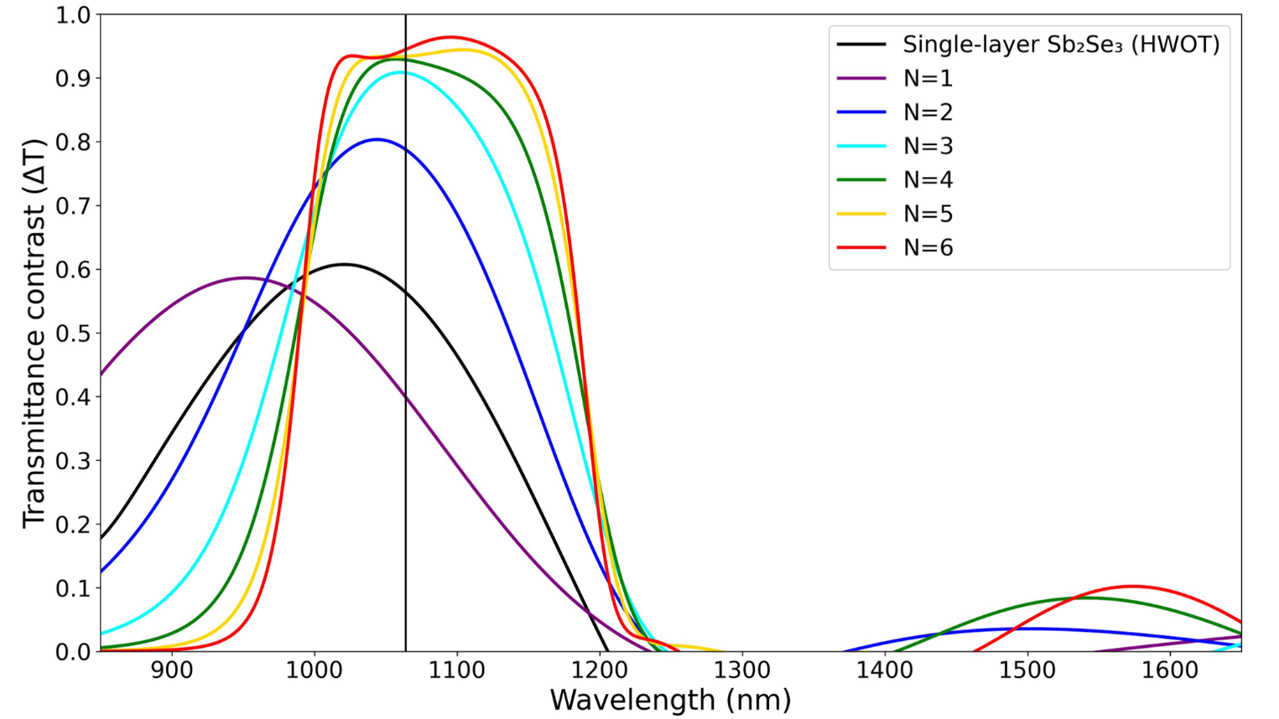
Transmittance contrast (ΔT) of a single-layer and edge-filter designs with different number of unit cells (N). The vertical black line indicates the interested 1064 nm wavelength
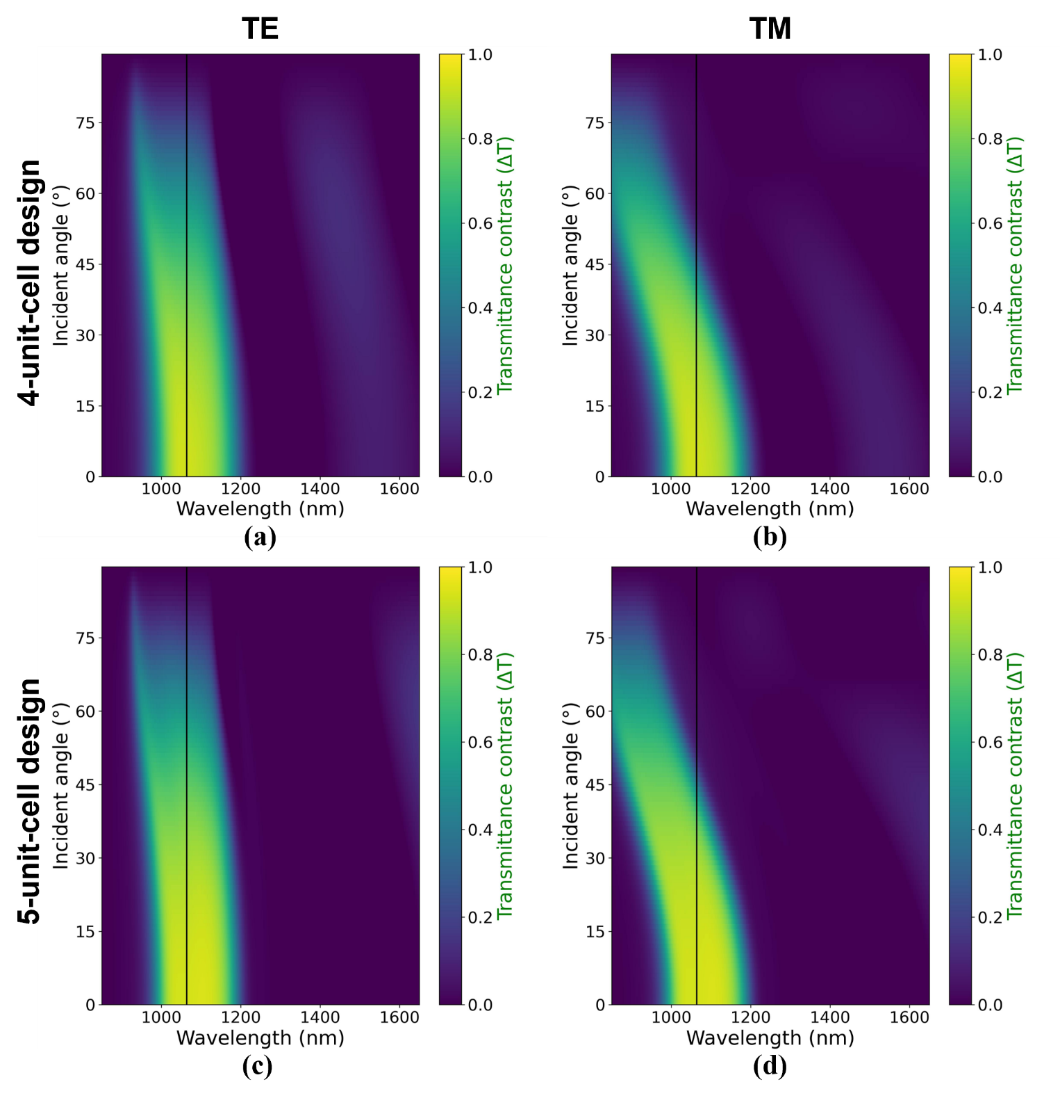
Transmittance contrast at different incident angles and polarization mode of 4-unit-cell and 5-unit-cell long-pass edge-filter designs.

With the simulated results shown in Table I and the two figures (Fig. 7, 8), one could say that it is difficult to decide which design is exactly the best without quantitative values from a figure-of-merit (FOM). However, we argue that quantitative analysis using FOM is partially a qualitative analysis. Because the selection of FOM equation or weighting are inherently subjective and can be done in such a way that any of the design can be the best. As an example, if we use unweight transmittance at 1064 nm over design thickness (t), ‘ΔT(1064)/t’, then 1-unit-cell design is actually the best, we can also weight this FOM to ‘0.9×ΔT(1064)/0.1×t‘ which result in 6-unit-cell being the best design. On the other side of the argument, a FOM is a useful tool for decision making and represent the purpose of the design. So, we decided to use unweighted spectral width with ΔT>90% over design thickness to reflect our goal of broadband filtering,
$FOM= {Δλ}_{ΔT>90\%} /t$ (23)
this results in 5-unit-cell being the best design. As a comparison, the value of each design are: FOM_{N=3} = 0.048, FOM_{N=4} =0.099, FOM_{N=5} =0.131, and FOM_{N=6} = 0.124 arbitrary unit. The reason why FOM values are not provided in Table 1 is to prevent out-of-context comparison. Again, we want to emphasize that the selection of FOM is subjective, and one should change the equation to match the applications.

- ENDURANCE SIMULATION OF 1064-NM OPTICAL FILTERS
Figure 9 presents the simulated endurance response at 1064 nm for the single-layer, four-unit-cell, and five-unit-cell edge-filter designs over 1.5 × 10⁶ switching cycles. Panels a–c show the evolution of the amorphous-state transmittance, T_{a}, and crystalline-state transmittance, T_{c}, whereas panels d–f show the corresponding percentage transmittance-contrast degradation, D_{pct}. For all three designs, the assumed cycle-dependent drift of the complex refractive index produces only gradual changes in the simulated optical response over the considered endurance range. The single-layer design exhibits a modest reduction in both T_{a} and T_{c}, while the four- and five-unit-cell edge filters retain high amorphous-state transmittance and show only a slight increase in crystalline-state transmittance at high cycle counts. Because the initial crystalline-state transmittance of the edge filters is very low, even a small increase in T_{c} can produce a larger value of D_{pct}. Nevertheless, the multilayer designs retain strong ON/OFF transmittance contrast at the final simulated cycle.
Panels g–i report the relative insertion-loss change in the amorphous state, ΔIL, referenced to the initial cycle. This quantity is defined as Eq. 21, therefore, ΔIL = 0 dB at C = 0 does not indicate zero intrinsic insertion loss of the device. Instead, it indicates that no additional insertion loss relative to the initial state has accumulated. The relative trends show the cycle-induced change in ON-state transmission independently of the different initial transmission levels of the three designs. The corresponding initial and final absolute insertion losses, IL_{abs}(0) and IL_{abs}(C_{f}) together with ΔIL(C_{f}), are summarized in Table II.
For the five-unit-cell edge filter, the initial amorphous-state transmittance of 93.6% corresponds to IL_{abs}(0) = 0.287 dB. At C_{f} =1.5 × 10⁶ cycles, the absolute insertion loss is 0.511 dB, giving a relative insertion-loss change of ΔIL(C_{f}) = 0.197 dB. The corresponding values for the single-layer and four-unit-cell filters are also reported in Table II. Thus, Fig. 9 and Table II together distinguish the initial intrinsic ON-state loss of each filter from the additional loss associated with the assumed cycle-dependent optical-property drift. The corresponding values for the six-unit-cell design are included in Table II to assess the dependence on unit-cell number. The results confirm that the endurance metrics are not monotonic from four to six-unit cells, which is expected for interference-based multilayer filters with different spectral conditions at the fixed operating wavelength.
The endurance response does not vary monotonically with the number of unit cells because the cycle-induced optical change is governed by the design-specific multilayer interference condition, rather than by the number of Sb₂Se₃ layers alone. Increasing the number of unit cells changes the total optical phase accumulation, the spectral-edge position, and the local spectral profile around the operating wavelength of 1064 nm. Consequently, the same assumed cycle-dependent perturbations in the real and imaginary refractive indices can produce different changes in T_{a}, T_{c}, and ΔIL for the four-, five-, and six-unit-cell filters. Therefore, neither the absolute insertion loss nor the relative insertion-loss change is expected to scale monotonically with the number of unit cells.
This interpretation is consistent with the contrast spectra in Fig. 7, where increasing the number of unit cells changes not only the peak transmittance contrast but also the spectral shape around 1064 nm. Thus, the operating wavelength occupies a different local interference condition for each multilayer design. The observed non-monotonic endurance response should therefore be interpreted as a design-dependent sensitivity to the assumed refractive-index drift and loss growth, rather than as a direct consequence of the amount of phase-change material.

TABLE II
Absolute and Relative ON-State Insertion Loss at 1064 nm
Design | T_{a}(0) (%) | IL_{abs}(0) (dB) | T_{a}(C_{f}) (%) | IL_{abs}(0) (dB) | ΔIL(0) (dB)
Single-layer | 93.5 | 0.292 | 92.8 | 0.325 | 0.033
4-unit-cell edge filter | 93.7 | 0.283 | 90.8 | 0.419 | 0.136
5-unit-cell edge filter | 93.6 | 0.287 | 88.9 | 0.511 | 0.197
6-unit-cell edge filter | 94.5 | 0.246 | 88.5 | 0.533 | 0.287
C_{f} = 1.5 × 10⁶ phase-switching cycles. The six-unit-cell results are included to examine the non-monotonic dependence of the endurance metrics on unit-cell number.
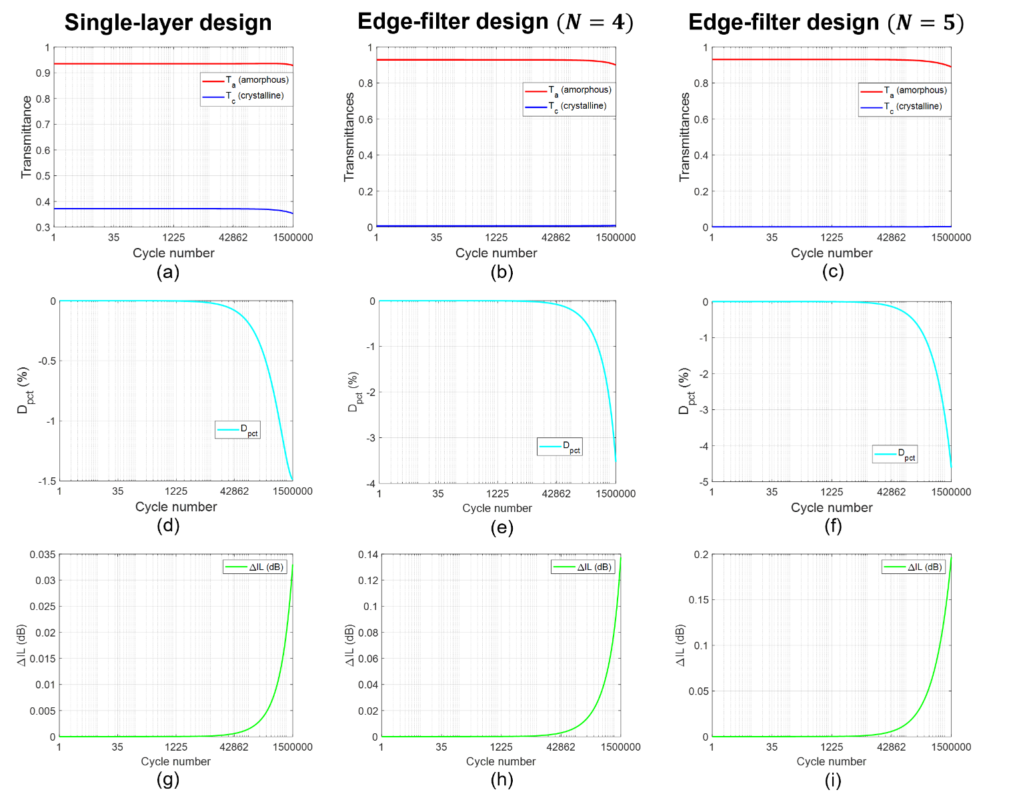
Optical endurance at 1064 nm of the single-layer, 4-unit-cell and 5-unit-cell edge-filter designs over 1.5×10⁶ phase-switching cycles. (a–c) Transmittance in amorphous (red) and crystalline phases (blue). (d–f) The percentage transmittance contrast degradation. (g–i) Relative insertion-loss change in amorphous phase, ΔIL, referenced to the initial cycle. Absolute insertion losses at the initial and final cycles are reported in Table II. The corresponding absolute and relative insertion-loss values for the six-unit-cell filter are also reported in Table II.

- SENSITIVITY ANALYSIS OF OPTICAL FILTER ENDURANCE
These simulation results confirm that designs with multiple layers of Sb₂Se₃ still maintain comparable transmittance endurance to a simple, single-layer design. Their larger D_{pct} might become a problem at larger switching cycle but is overall negligible in the confine of our simulation. Overall, the edge-filter designs still have a higher transmittance contrast and a lower insertion loss after 1.5×10⁶ cycles.
To assess the robustness of the endurance prediction against uncertainty in the phenomenological optical-drift parameters, a three-case sensitivity analysis was performed for the five-unit-cell Sb₂Se₃ long-pass edge-filter at 1064 nm. The low-degradation, nominal, and high-degradation cases employed (α_{p}, β_{p}) = (0.5 × 10⁻⁷, 1.0 × 10⁻⁷), (1.0 × 10⁻⁷, 2.0 × 10⁻⁷), and (1.5 × 10⁻⁷, 3.0 × 10⁻⁷) cycles⁻¹, respectively. Thus, the low- and high-degradation cases correspond to -50 % and +50 % variations relative to the nominal parameter values. The same parameter pair was applied to the amorphous and crystalline Sb₂Se₃ phases to isolate the influence of the overall degradation magnitude.
Fig. 10a and Fig. 10b show the calculated amorphous-state and crystalline-state transmittances, respectively, over 1.5 × 10⁶ cycles. The amorphous-state transmittance exhibits only a limited decrease for all three cases, with the largest change occurring in the high-degradation case. This behavior is consistent with the assumed increase in the extinction coefficient and gradual real-index drift, which detune the initial interference condition of the multilayer edge-filter. The crystalline-state transmittance remains at the 10⁻³ level throughout the simulation, indicating that the OFF state remains strongly suppressed even under the high-degradation conditions. The slightly increasing T_{c} at large cycle numbers reflects the modelled shift of the multilayer spectral response caused by the phase-dependent changes in complex refractive index.
The sensitivity of the transmitting contrast is shown in Fig. 10c. As expected, the contrast degradation decreases with the assumed drift and loss-growth rates. Nevertheless, all parameter cases preserve the same qualitative operating behavior: a high-transmittance amorphous ON state and a strongly attenuated crystalline OFF state. Therefore, the principal filtering mechanism and the high-contrast operation of the five-unit-cell edge-filter are not dependent on a single arbitrarily selected coefficient pair.
Fig. 10d shows the corresponding relative insertion-loss evolution of the amorphous state. The low-, nominal-, and high-degradation cases produce insertion losses of approximately 0.10 dB, 0.20 dB, and 0.31 dB, respectively, at 1.5 × 10⁶ cycles. Thus, even the deliberately conservative high-degradation case yields a relative insertion loss change of approximately 0.31 dB over the simulated endurance range. These results indicate that the proposed filter retains low-loss ON-state operation over the tested parameter range.
Overall, the sensitivity analysis confirms that the main conclusion of this work is robust to ±50 % variations in the assumed endurance coefficients. The five-unit-cell Sb₂Se₃ edge-filter remains operational over 1.5 × 10⁶ cycles and maintains a strongly suppressed crystalline-state transmission for all three cases. Because $α_{p}$and $β_{p}$are phenomenological parameters rather than direct fits to cycle-resolved measurements of n_{p}(C) and k_{p}(C) at 1064 nm, these results should be interpreted as a robustness assessment of the model. Future experimental work using in-situ cycling together with ellipsometry, or calibrated transmission and reflection measurements, will be required for direct parameter calibration.
The calculated endurance trends should be interpreted within the scope of the phenomenological model. The present approach does not resolve the microscopic mechanisms responsible for optical-property drift during phase switching. A more predictive framework would require coupled phase-transition kinetics, thermal transport, and structural-evolution simulations, calibrated using cycle-resolved optical and electrical measurements. Nevertheless, the sensitivity analysis demonstrates that the device-level conclusion is robust to the tested range of assumed refractive-index drift and loss-growth coefficients.

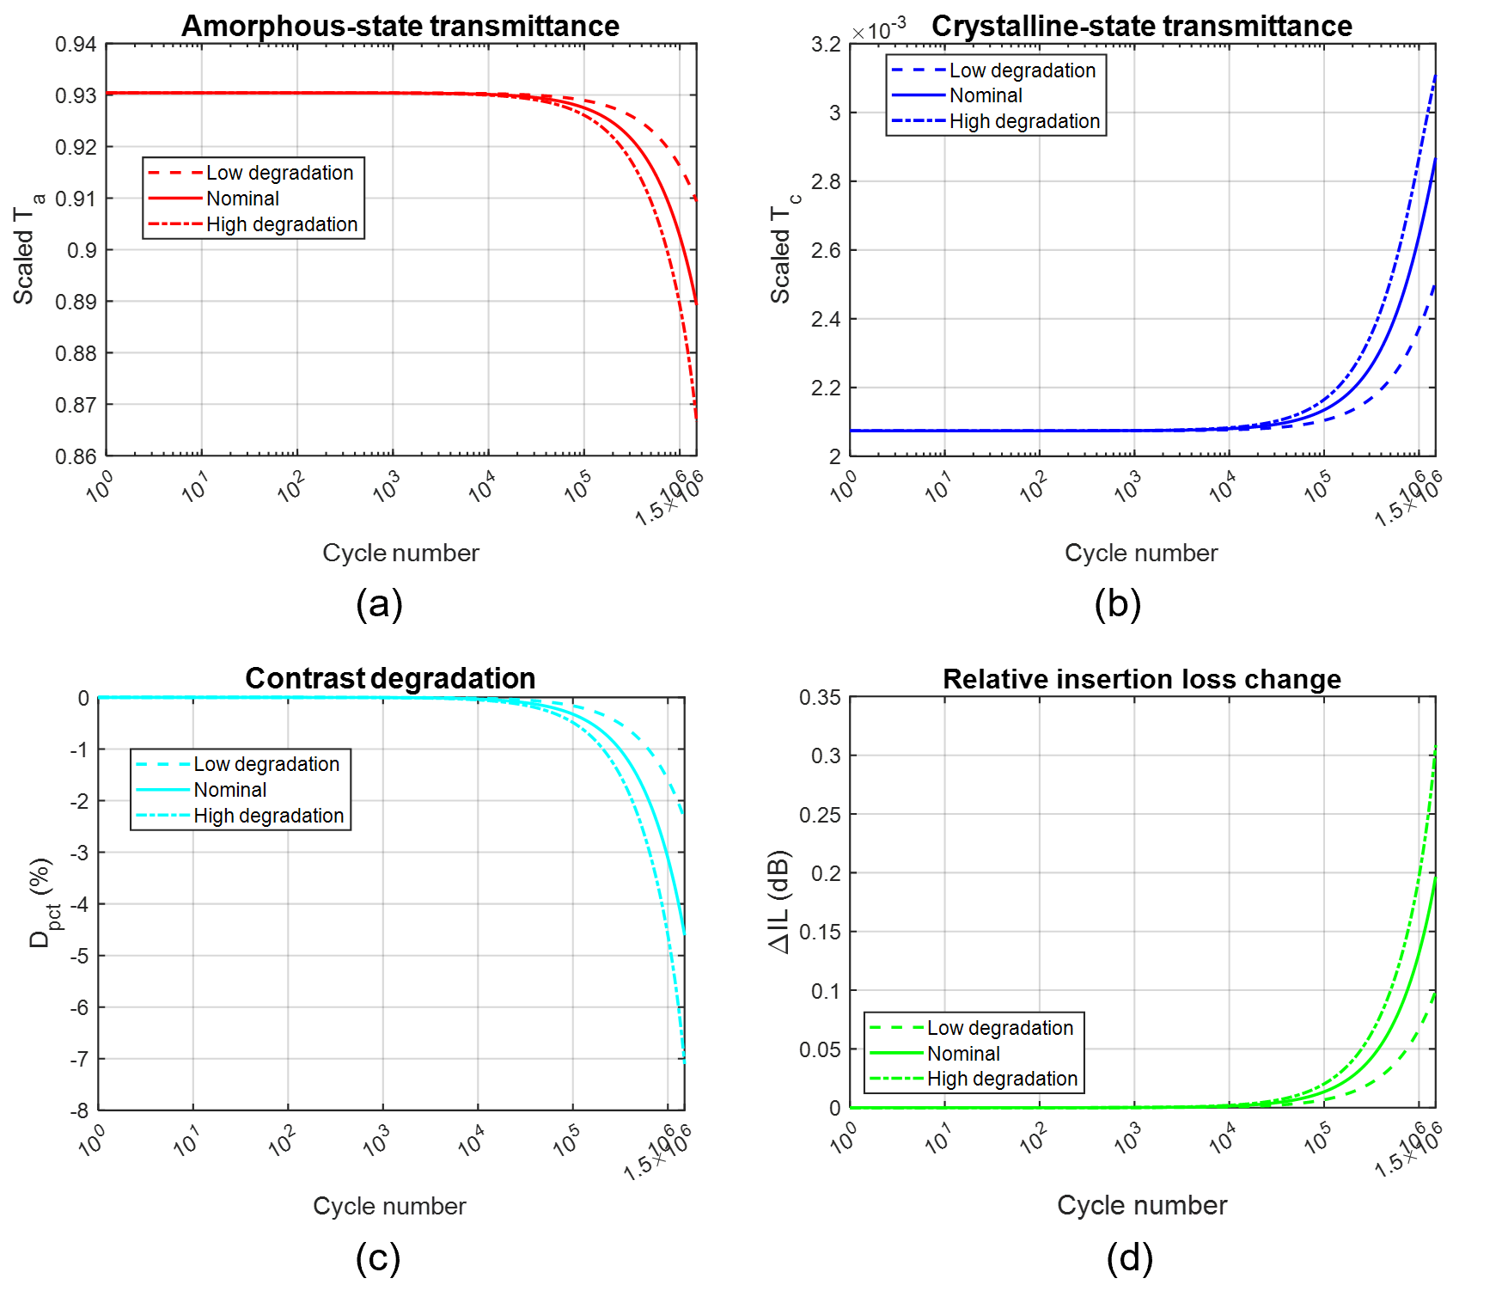
Sensitivity analysis of the five-unit-cell Sb₂Se₃ edge-filter at 1064 nm over 1.5 × 10⁶ cycles. (a) Amorphous-state transmittance, T_{a}; (b) crystalline-state transmittance, T_{c}; (c) percentage transmittance-contrast degradation, D_{pct}; and (d) amorphous-state relative insertion loss change, ΔIL. The low-degradation, nominal, and high-degradation cases use (α_{p}, β_{p} )=(0.5 × 10⁻⁷, 1.0 × 10⁻⁷), (1.0 × 10⁻⁷, 2.0 × 10⁻⁷), and (1.5 × 10⁻⁷, 3.0 × 10⁻⁷) cycles⁻¹, respectively. The same parameter values were applied to the amorphous and crystalline phases.

- TRANSMITTANCE-AMPLITUDE TUNABILITY AND OPTIMIZATION.
Edge-filter designs have multiple layers of Sb₂Se₃ which complicates the phase switching setup. When laser-induced heating is used as a switching method, the phase transition of every Sb₂Se₃ layer does not occur simultaneously and the transmission changes gradually. This effect is shown in the optical limiter of Sarangan, et al. [3] Their device use a similar long-pass edge-filter design but the H layers are GST instead of Sb₂Se₃, and the L layers are SiO₂ instead of MgF₂. Their experimental results showed that the phase switching of GST layers occurs layer-by-layer in an order that is determined by the changes in the optical field distribution and thermal crosstalk between layers, which does not necessarily start from layer in the air -side to the substrate-side (top to bottom). However, our device is intended to be used as a transmittance-tunable filter that does not require a fast switching speed; therefore, electrical heating is also available as an alternative phase switching method. The ability to manually control the phase of each Sb₂Se₃ layer enables the filter to have multiple transmittance values. Using the 5-unit-cell edge-filter design described in Table I, which consists of 11 layers of Sb₂Se₃ and MgF₂ (six layers of Sb₂Se₃), there would be a total of 2⁶ configurations for the Sb₂Se₃ phases. Figure 11 highlights some of these configurations; the legend denotes Sb₂Se₃ in the amorphous (a) or crystalline phase (c), and the ordering from left to right is from the substrate to the air side (f₁ to f₆). With the correct phase configuration, the transmittance can be gradually reduced from peak of 93.4% to 0.0%.
The peak transmittance contrast of each design shown previously in Fig. 7 does not always correspond to the desired operating wavelength of 1064 nm. So, an optimization algorithm can be used to improve the optical performance. A simple merit function found in OpenFilters [40] is used in this example. The optimization goal for the 5-unit-cell edge-filter design is to have a transmittance value of at least 97% from 1000 to 1200 nm at intervals of every 20 nm. The optimization took less than 5 s, and the new design now required 304.2 nm of Sb₂Se₃, 25% more than the original design, but the overall thickness is now 845.6 nm, 7% less than the original, the thickness of each layer is shown in Table III. Figure 12a shows the transmittance of the original (green) and optimized designs (blue) in the amorphous (solid) and crystalline phases (dotted). Overall, the optimized design has a higher transmittance in the desired 1000 to 1200 nm spectrum, but the spectral profile has been blue shifted by a small amount. The transmittance contrast at 1064 nm (Fig. 12b) of the optimized design is also higher, 95.8%, compared to 93.4% of the original. The transmittance contrast FWHM also extended slightly to 207.4 nm (original: 197.0 nm)

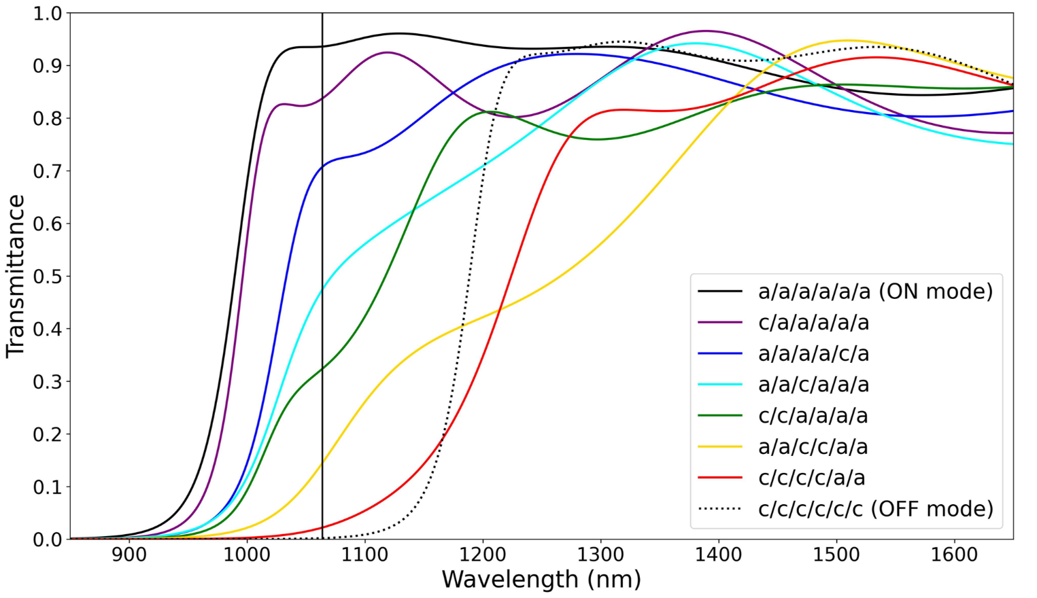
Transmittance of the five-unit-cell edge-filter design in 8 different configurations. Each Sb₂Se₃ layer is in amorphous (a) or crystalline (c) phases, and the layout ordering from left to right is substrate-side to air-side.

TABLE III
Thickness of Each Layer Before and After Optimization

Design | SiO₂ | Sb₂Se₃ | MgF₂ | Sb₂Se₃ | MgF₂ | Sb₂Se₃ | MgF₂ | Sb₂Se₃ | MgF₂ | Sb₂Se₃ | MgF₂ | Sb₂Se₃
Original | 3 mm | 24.3 | 134.0 | 48.5 | 134.0 | 48.5 | 134.0 | 48.5 | 134.0 | 48.5 | 134.0 | 24.3
Optimized | 3 mm | 46.1 | 67.5 | 59.3 | 148.1 | 55.0 | 89.3 | 50.0 | 145.3 | 63.3 | 91.2 | 30.5
Original design is the 5-unit-cell long-pass edge filter. The thickness unit of Sb₂Se₃ and MgF₂ is nm.

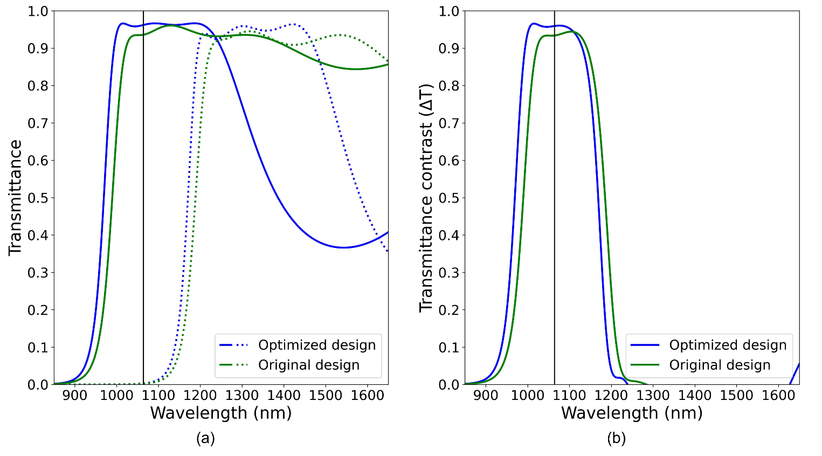
- Transmittance comparison of 5-unit-cell edge-filter design before (green) and after (blue) optimization. (a) The transmittance in ON mode (solid) and OFF mode (dotted). (b) The transmittance contrast (ΔT). An optimized design has higher optical performance from 900 to 1200 nm, but the high-ΔT region has been blueshifted by a small amount.

- COMPARISON WITH OTHER OPTICAL DEVICES
In order to understand the benefits and limitations of our proposed five-unit-cell optical filter, we create Table IV comparing our proposed design to other recent optical devices (optical filters [15, 17, 28], waveguide switch [27], optical limiter [3], and non-PCM antireflection coating [18]). The table is written in an order of similar design purpose, not necessary from similar material. When directly compared to other 1064-nm PCM-based optical filter [17, 28], our design has higher transmittance in amorphous phase (T_{ON}), higher transmittance contrast (ΔT). These can be attributed from the low-loss property in Sb₂Se₃ and the design architecture (edge filter), but not necessary from optimization. However, edge-filter design required more layers and the device size is much thicker than [17] (but less than [28]). When compared to non-PCM-based antireflection coating [18], our design is thicker and T_{ON} is still lower which indicate further optimization may be possible.
It is important to remember that Table IV is not for direct benchmarking, it is unfair to compares theoretical simulation work to real fabrication measurement. The purpose is to highlight Sb₂Se₃-based edge filter is suitable for high-ΔT application where device size is not a concern.

- PRACTICAL FABRICATION AND IMPLEMENTATION CONSIDERATIONS
The proposed Sb₂Se₃/MgF₂ edge-filter is a planar multilayer structure that can, in principle, be fabricated by sequential thin-film deposition on fused-silica, glass, or Si/SiO₂ substrates. Unlike nanostructured metasurfaces, its normal-incidence filtering function originates from thin-film interference and does not require subwavelength lithographic patterning. This planar configuration is therefore compatible with scalable optical-coating processes, although experimental verification of deposition conditions and optical performance is still required.

TABLE IV
Comparison Between Our Five-Unit-Cell Designs and Other Optical Devices

Design | PCM | Operating wavelength | Number of layer | Device size (nm) | T_{ON} (%) | T_{OFF} (%) | ΔT (%) | Reference
5-unit-cell long-pass edge filter ⁽¹⁾ | Sb₂Se₃ | 1064 | 11 | 912 | 93.6 | 0.2 | 93.4 | -
Optimized 5-unit-cell long-pass edge filter ⁽¹⁾ | Sb₂Se₃ | 1064 | 11 | 845.6 | 96.1 | 0.3 | 95.8 | -
Fabry–Pérot cavity single-channel filter ⁽¹⁾ | Sb₂Se₃ | 941 | 7 | 230 | 71 | ~11 | ~60 | [17]
Fabry–Pérot cavity multi-channel filter | Sb₂Se₃ | ~1070 | 7 | 245 | ~50 | ~6 | ~44 | [17]
Fabry–Pérot cavity single-channel filter (2 DBR, 4% vol. frac.) ⁽¹⁾ | VO₂-P4VP | 1064 | 9 | 1889 (calculate from OT) | ~61 | ~25 | ~36 | [28]
Resonat cavity two-channel filter | GSST | 850 | 7 | 160 | ~75 | 0 | ~75 | [15]
Micro-ring resonator optical switch | Sb₂Se₃ | 1551.3 | 1 | 1300 x 700 | 93 | 1 | 92 | [27]
4-unit-cell long-pass optical limiter | GST | ~1700–2000 | 9 | 1059 | ~80 | 0 | ~80 | [3]
Three-layer AR coating | Non PCM | 550 | 3 | 301 | 97.2 | - | - | [18]
Four-layer AR coating (double sided) | Non PCM | 550 | 4×2=8 ⁽²⁾ | 401×2=802 ⁽²⁾ | 99.4 | - | - | [18]
⁽¹⁾ Simulation data. ⁽²⁾ The ‘× 2’ is due to double-sided deposition (front and backside).

A practical fabrication process may begin with conventional substrate cleaning, followed by alternating deposition of Sb₂Se₃ phase-change layers and MgF₂ dielectric spacer layers according to the optimized physical thickness obtained from the transfer-matrix design. Sb₂Se₃ films for photonic applications have been prepared by thin-film deposition routes, and reversible low-loss optical switching of Sb₂Se₃ has been demonstrated experimentally [22, 24, 25]. During deposition, the substrate temperature and overall thermal budget should be controlled to prevent unintended crystallization and preserve the initial amorphous state of Sb₂Se₃ [22, 24]. For the MgF₂ spacer layers, the deposited optical constants and thicknesses should be calibrated because the refractive index and microstructure of MgF₂ thin films depend on film properties and deposition conditions [32]
Since the spectral edge and transmittance contrast arise from multilayer interference, deviations in the individual layer thicknesses, refractive indices, film density, interfacial roughness, and thickness uniformity can shift the operating wavelength and reduce the transmittance contrast [18, 30]. These fabrication tolerances can be managed through deposition-rate calibration, in-situ thickness monitoring, substrate rotation, and post-fabrication spectroscopic ellipsometry together with normal-incidence transmission/reflection measurements [18]. In particular, the optical constants of the fabricated Sb₂Se₃ and MgF₂ films should be used to update the transfer-matrix model before comparing the measured and simulated spectra [22, 30, 32].
Environmental protection of the Sb₂Se₃ layers should also be considered. A thin dielectric capping layer, such as SiO₂ or Al₂O₃, may be incorporated after deposition of the multilayer stack to reduce contamination and environmental exposure [41]. Because a cap layer changes the boundary conditions and optical thickness of the complete multilayer system, its complex refractive index and thickness must be included in the final transfer-matrix optimization [30]. This consideration is particularly relevant because the phase-transition behavior and long-term endurance of optical phase-change materials depend on the material environment, thermal conditions, and cycling protocol [25, 38, 39, 41].
For proof-of-concept validation, the amorphous and crystalline states can first be prepared by controlled thermal annealing and optical reset procedures, followed by normal-incidence spectral-transmission measurements [22, 24]. Optical switching of Sb₂Se₃ has been demonstrated using laser-pulse excitation, while electrical actuation is a potential alternative for integrated photonic implementations [15, 24]. For active multilayer operation, achieving spatially uniform switching across all Sb₂Se₃ layers is an important engineering challenge because optical-field intensity and temperature can vary through the stack thickness. The heater or optical-pulse configuration must therefore provide sufficient switching energy while minimizing thermal crosstalk, excess absorption, and potential damage to adjacent MgF₂ layers [25, 38, 39]. Future work will experimentally determine fabrication tolerances, deposited optical constants, switching thresholds, spectral response, and cycling endurance for the complete Sb₂Se₃/ MgF₂ multilayer filter.
Although the optical constants used in the simulations were obtained from experimentally measured Sb₂Se₃ data [32], the calculated spectral response of the complete Sb₂Se₃/MgF₂ multilayer filter has not yet been experimentally validated. The present work should therefore be regarded as a simulation-guided design study. Experimental validation will require fabrication of the complete stack, measurement of its deposited thicknesses and complex refractive indices, and comparison of the measured amorphous- and crystalline-state spectra with the transfer-matrix predictions.

- LIMITATIONS AND FUTURE WORK SUGGESTIONS
One of the limitations mentioned by several reviewers is the lack of experimental validation. Furthermore, complications can arise during fabrication process. In the only other published Sb₂Se₃-based optical filter we could find at this wavelength [17], their experimental values differ greatly from simulated data. To account for these concerns, we simulate the transmittance contrast (ΔT) of our proposed 5-unit-cell designs (pre- and post-optimized) by randomly varying the thickness of each layer by ±10%, and refractive index of each material by ±2% for 200 simulations for each design (Monte Carlo). The simulated results are shown in Fig. 13, the solid color line is the ideal ΔT (same value as Fig. 12b), the transparent area are plotted from 5th and 95th percentiles of the 200 simulations. At 1064 nm, the worst-case-scenario simulations have (a) ΔT_{original} = 74% and (b) ΔT_{optimized} = 79%, which are still slightly higher than filter shown in Table IV. Firstly; it can be pointed out that optimization not only increase the optical performance but also increase the tolerance to fabrication imperfection. And secondly; in an unoptimized design (Fig. 13a), there are possibilities that fabrication imperfections could cause the ΔT(1064) to be increased by ~3% from the ideal design, this effect is not observed in the optimized design (Fig. 13b). These two discussion points further support the use of thickness-optimization algorithm after the initial design process, even a simple merit function that can be done quickly is encouraged.
In this work, we proposed layer-dependent phase switching, which allows for a transmittance tuning in multiple steps, from peak 93% down to 0% (Fig. 11). However, no actual thermal simulation has been done. This is because such simulations require a more complex multiphysics simulation, which falls outside the scope of the TMM simulation in this work. Simulating thermal behaviour is beneficial for realizing phase switching mechanisms and can be an interesting future works.
A finite-thickness effect is a physical phenomenon where the complex refractive index of an ultra-thin film is not constant like bulk film but is a function of thickness. The thinnest layers in this work are the first and last Sb₂Se₃ layers of an unoptimized five-unit-cell design (half-QWOT thick, 24.3 nm) which is around where this effect starts to manifest [42]. The Sb₂Se₃ refractive index dataset used in this paper is measured from only 40-nm thick film [22], so we currently cannot model this effect.
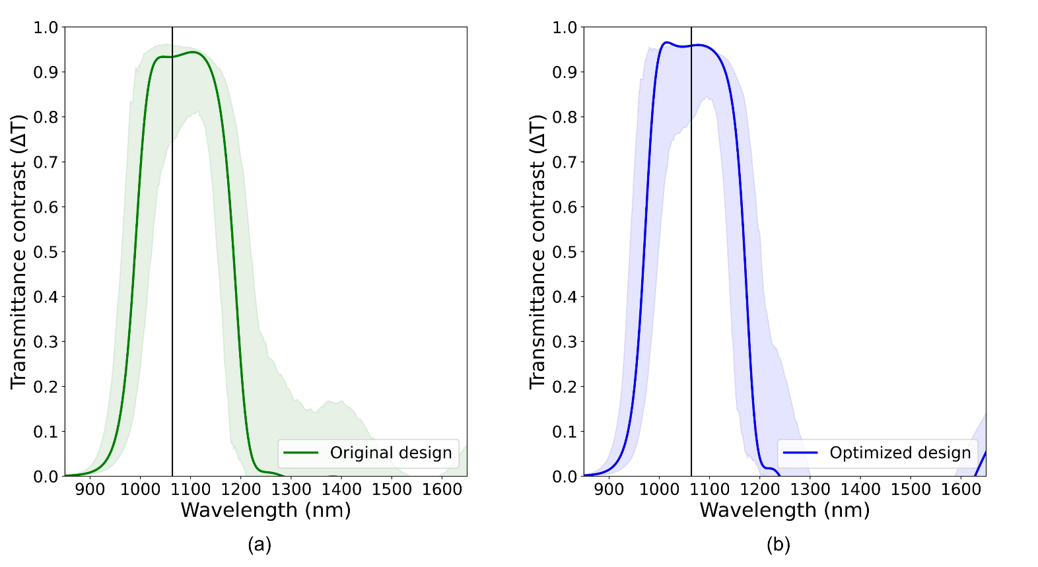
Simulation of transmittance contrast of our five-unit-cell designs before (a) and after (b) optimization. The transparent area are the 5th and 95th percentiles from 200 TMM simulations.

- CONCLUSIONS
Using TMM simulation, we have shown that Sb₂Se₃ is a suitable PCM for high-efficient, broadband, tunable transmittance-amplitude optical filters operating around 1064 nm wavelength. The 5-unit-cell long-pass edge-filter design has the best compromise between high and stable ΔT for broadband operation, device size, and design complexity. This design required six Sb₂Se₃ layers and five MgF₂ layers and is 912 nm thick. Transmittance at 1064 nm in the ON mode is 93.4% and 0.2% in OFF mode, a contrast of 93.4% with ~200 nm FWHM. Simulations show that after 1.5×10⁶ phase switching cycles, the transmittance contrast degradation and insertion loss in ON mode is still within acceptable ranges. The multilayer nature of edge-filter design enables the modulation of transmittance amplitude in a step by changing the phase of each Sb₂Se₃ layer. However, thermal simulation required for realizing phase switching mechanism has not been done yet. A quick and simple optimization algorithm can increase the ΔT from 1000–1200 nm and is worth doing for any future designs. When compared to others works, our design has better transmittance contrast but required more layers and the overall size is larger. We also simulate fabrication imperfections by varying each layer thickness and each material refractive index from design value, the results show that the designs still have higher transmittance contrast than design in other works.
In addition, a three-case sensitivity analysis was conducted by varying the phenomenological refractive-index drift and loss-growth coefficients, α_{p} and β_{p}, by ±50 % relative to their nominal values. Across the tested parameter range, the five-unit-cell Sb₂Se₃ edge-filter retained a high-transmittance amorphous ON state and a strongly suppressed crystalline OFF state after 1.5 × 10⁶ cycles. The calculated ON-state relative insertion loss change remained below -0.31 dB, even for the high-degradation case, indicating that the main endurance conclusion is robust to the assumed coefficient variation. Because the endurance coefficients are phenomenological rather than directly fitted to cycle-resolved measurements of the complex refractive index, future work should experimentally determine the phase-dependent evolution of n_{p} and k_{p} during cycling at the operating wavelength.
The endurance results represent a phenomenological robustness assessment rather than a physics-based phase-transition lifetime prediction; future work should combine cycle-resolved measurements with coupled multiphysics modelling to establish physically calibrated degradation coefficients.
From a fabrication perspective, the proposed device is a planar multilayer stack that is compatible with sequential thin-film deposition and does not require nanoscale lithographic patterning for normal-incidence filtering. Future work will experimentally establish deposition tolerances, incorporate a suitable capping and switching scheme, and validate the spectral response, phase-switching behavior, and cycling endurance of the fabricated Sb₂Se₃/MgF₂ multilayer filters.

ACKNOWLEDGMENT
The authors greatly appreciate the discussion, grammatical and format suggestions from Nathan Hagen, Center for Optical Research and Education, Utsunomiya University, Japan.
DISCLOSURE
The authors declare no competing interests.
DATA AVAILABILITY
Data and simulation codes underlying the results presented in this paper may be obtained from the corresponding author upon a reasonable request.
DECLARATION OF AI USAGE
Gemini was used for code debugging and grammar correction. Consensus was used to help with the initial literature review. The authors have reviewed and edited the content as needed after using these tools.
References
[1] K. Matuszek, M. Kar, J. M. Pringle, and D. R. MacFarlane, "Phase Change Materials for Renewable Energy Storage at Intermediate Temperatures," Chemical Reviews, vol. 123, no. 1, pp. 491–514, 2023/01/11 2023, doi: 10.1021/acs.chemrev.2c00407.
[2] R. Matos and N. Pala, "A Review of Phase-Change Materials and Their Potential for Reconfigurable Intelligent Surfaces," Micromachines, vol. 14, no. 6, p. 1259, 2023. [Online]. Available: https://www.mdpi.com/2072-666X/14/6/1259.
[3] A. Sarangan, J. Duran, V. Vasilyev, N. Limberopoulos, I. Vitebskiy, and I. Anisimov, "Broadband Reflective Optical Limiter Using GST Phase Change Material," IEEE Photonics Journal, vol. 10, no. 2, pp. 1–9, 2018, doi: 10.1109/jphot.2018.2796448.
[4] K. Aryana et al., "Optical and thermal properties of Ge2Sb2Te5, Sb2Se3, and Sb2S3 for reconfigurable photonic devices [Invited]," Opt. Mater. Express, vol. 13, no. 11, 2023, doi: 10.1364/ome.503178.
[5] W. Jia, R. Menon, and B. Sensale-Rodriguez, "Unique prospects of phase change material Sb2Se3 for ultra-compact reconfigurable nanophotonic devices," Opt. Mater. Express, vol. 11, no. 9, pp. 3007–3014, 2021/09/01 2021, doi: 10.1364/OME.435979.
[6] S. Blundell et al., "Ultracompact Programmable Silicon Photonics Using Layers of Low-Loss Phase-Change Material Sb2Se3 of Increasing Thickness," ACS Photonics, vol. 12, no. 3, pp. 1382–1391, 2025/03/19 2025, doi: 10.1021/acsphotonics.4c01789.
[7] C. Wan et al., "Ultrathin Broadband Reflective Optical Limiter," Laser & Photonics Reviews, vol. 15, no. 6, p. 2100001, 2021, doi: https://doi.org/10.1002/lpor.202100001.
[8] X. Ling, X. Pang, X. Chen, and Z. Shao, "Broadband mid-infrared optical limiter based on&#x00A0;vanadium dioxide phase transition," J. Opt. Soc. Am. B, vol. 42, no. 9, pp. 2062–2067, 2025/09/01 2025, doi: 10.1364/JOSAB.569492.
[9] M. Gandolfi et al., "Optical Limiting Thin Multilayer Films Based On Phase Transition In VO2," in 2022 Sixteenth International Congress on Artificial Materials for Novel Wave Phenomena (Metamaterials), 12–17 Sept. 2022 2022, pp. 148–150, doi: 10.1109/Metamaterials54993.2022.9920767. [Online]. Available: https://ieeexplore.ieee.org/stampPDF/getPDF.jsp?tp=&arnumber=9920767&ref=
[10] A. Tognazzi et al., "Opto-thermal dynamics of thin-film optical limiters based on the VO2 phase transition," Opt. Mater. Express, vol. 13, no. 1, pp. 41–52, 2023/01/01 2023, doi: 10.1364/OME.472347.
[11] Y. Li et al., "An Adaptive Optical Limiter Based on a VO2/GaN Thin Film for Infrared Lasers," Photonics, vol. 13, no. 2, p. 148, 2026. [Online]. Available: https://www.mdpi.com/2304-6732/13/2/148.
[12] Y. Zhang et al., "Broadband transparent optical phase change materials for high-performance nonvolatile photonics," Nature Communications, vol. 10, no. 1, p. 4279, 2019/09/30 2019, doi: 10.1038/s41467-019-12196-4.
[13] H. Li, D. Zeng, Y. Huang, Q. Huang, and X. Zhang, "Ultra-compact, ultra-low-loss and broadband 2 x 2 nonvolatile optical switch based on Sb(2)Se(3) phase change material," Opt Express, vol. 32, no. 20, pp. 35287–35297, Sep 23 2024, doi: 10.1364/OE.534645.
[14] R. R. Ghosh and A. Dhawan, "Numerical modeling of an integrated non-volatile reflector switch and mode converter switch based on a low loss phase change material (Sb2Se3) in SiN platforms," Opt. Mater. Express, vol. 12, no. 11, pp. 4268–4283, 2022/11/01 2022, doi: 10.1364/OME.462912.
[15] R. Heenkenda, K. Hirakawa, and A. Sarangan, "Tunable optical filter using phase change materials for smart IR night vision applications," Opt. Express, vol. 29, no. 21, pp. 33795–33803, 2021/10/11 2021, doi: 10.1364/OE.440299.
[16] Y.-S. Huang et al., "Tunable structural transmissive color in fano-resonant optical coatings employing phase-change materials," Materials Today Advances, vol. 18, p. 100364, 2023/06/01/ 2023, doi: https://doi.org/10.1016/j.mtadv.2023.100364.
[17] M. Cui et al., "Tunable multi-channel optical filter based on the near-infrared ultralow-loss phase change material Sb2Se3," Opt. Express, vol. 34, no. 5, pp. 7378–7387, 2026/03/09 2026, doi: 10.1364/OE.586098.
[18] R. Patel, N. Patel, N. Bazzanella, and A. Miotello, "Fabricating multilayer antireflective coating for near complete transmittance in broadband visible light spectrum," Optical Materials, vol. 108, p. 110415, 2020/10/01/ 2020, doi: https://doi.org/10.1016/j.optmat.2020.110415.
[19] X. Tian and Z.-Y. Li, "An Optically-Triggered Switchable Mid-Infrared Perfect Absorber Based on Phase-Change Material of Vanadium Dioxide," Plasmonics, vol. 13, no. 4, pp. 1393–1402, 2018/08/01 2018, doi: 10.1007/s11468-017-0643-9.
[20] C. Liu et al., "Tunable nonlinear optical absorption in amorphous and crystalline Sb2Se3 thin films," Journal of Alloys and Compounds, vol. 791, pp. 753–760, 2019/06/30/ 2019, doi: 10.1016/j.jallcom.2019.03.295.
[21] I. O. Oguntoye, S. Padmanabha, M. Hinkle, T. Koutsougeras, A. J. Ollanik, and M. D. Escarra, "Continuously Tunable Optical Modulation Using Vanadium Dioxide Huygens Metasurfaces," ACS Applied Materials & Interfaces, vol. 15, no. 34, pp. 41141–41150, 2023/08/30 2023, doi: 10.1021/acsami.3c08493.
[22] M. Delaney, I. Zeimpekis, D. Lawson, D. W. Hewak, and O. L. Muskens, "A New Family of Ultralow Loss Reversible Phase‐Change Materials for Photonic Integrated Circuits: Sb2S3 and Sb2Se3," Advanced Functional Materials, vol. 30, no. 36, 2020, doi: 10.1002/adfm.202002447.
[23] A. A. Burtsev et al., "Physical properties’ temperature dynamics of GeTe, Ge2Sb2Te5 and Ge2Sb2Se4Te1 phase change materials," Materials Science in Semiconductor Processing, vol. 150, p. 106907, 2022/11/01/ 2022, doi: https://doi.org/10.1016/j.mssp.2022.106907.
[24] D. Lawson, S. Blundell, M. Ebert, O. L. Muskens, and I. Zeimpekis, "Optical switching beyond a million cycles of low-loss phase change material Sb2Se3," Opt. Mater. Express, vol. 14, no. 1, 2023, doi: 10.1364/ome.509434.
[25] M. S. Alam et al., "Fast Cycling Speed with Multimillion Cycling Endurance of Ultra-Low Loss Phase Change Material (Sb2Se3) by Engineered Laser Pulse Irradiation," Advanced Functional Materials, vol. 34, no. 14, p. 2310306, 2024, doi: https://doi.org/10.1002/adfm.202310306.
[26] X. Chen, J. Lin, and K. Wang, "A Review of Integrated Photonic Devices Using Sb2Se3," Advanced Physics Research, vol. 4, no. 1, p. 2400080, 2024, doi: 10.1002/apxr.202400080.
[27] Q. Zhang, Q. Hong, and Z. Zhu, "Low-loss Optical Switching Based on Phase-change Material Sb2Se3 in a Micro-ring Resonator," Journal of Physics: Conference Series, vol. 2597, p. 012020, 09/01 2023, doi: 10.1088/1742-6596/2597/1/012020.
[28] Y. Liu et al., "Design of near-infrared solid-state tunable Fabry-Perot filters based on VO2/P4VP films," Opt. Express, vol. 32, no. 19, pp. 32585–32596, 2024/09/09 2024, doi: 10.1364/OE.530226.
[29] B. Sun et al., "Integrated Bragg grating filters based on silicon-Sb2Se3 with non-volatile bandgap engineering capability," Opt. Express, vol. 31, no. 17, pp. 27905–27913, 2023/08/14 2023, doi: 10.1364/OE.495196.
[30] A. Sarangan, Optical Thin Film Design, 1st Edition ed. Boca Raton: CRC Press, 2020.
[31] D. Franta, D. Nečas, I. Ohlídal, and A. Giglia, Optical characterization of SiO2 thin films using universal dispersion model over wide spectral range (SPIE Photonics Europe). SPIE, 2016.
[32] D. Franta, D. Nečas, A. Giglia, P. Franta, and I. Ohlídal, "Universal dispersion model for characterization of optical thin films over wide spectral range: Application to magnesium fluoride," Applied Surface Science, vol. 421, pp. 424–429, 2017/11/01/ 2017, doi: https://doi.org/10.1016/j.apsusc.2016.09.149.
[33] S. V. Zhukovsky et al., "Experimental Demonstration of Effective Medium Approximation Breakdown in Deeply Subwavelength All-Dielectric Multilayers," Physical Review Letters, vol. 115, no. 17, p. 177402, 10/23/ 2015, doi: 10.1103/PhysRevLett.115.177402.
[34] Y. Li et al., "Preparation of mechanically stable triple-layer interference broadband antireflective coatings with self-cleaning property by sol–gel technique," RSC Advances, 10.1039/C7RA00844A vol. 7, no. 24, pp. 14660–14668, 2017, doi: 10.1039/C7RA00844A.
[35] D. Franta, P. Franta, J. Vohánka, M. Čermák, and I. Ohlídal, "Determination of thicknesses and temperatures of crystalline silicon wafers from optical measurements in the far infrared region," Journal of Applied Physics, vol. 123, no. 18, 2018, doi: 10.1063/1.5026195.
[36] L. Y. Beliaev, E. Shkondin, A. V. Lavrinenko, and O. Takayama, "Optical, structural and composition properties of silicon nitride films deposited by reactive radio-frequency sputtering, low pressure and plasma-enhanced chemical vapor deposition," Thin Solid Films, vol. 763, p. 139568, 2022/12/01/ 2022, doi: https://doi.org/10.1016/j.tsf.2022.139568.
[37] M. N. Polyanskiy, "Refractiveindex.info database of optical constants," Scientific Data, vol. 11, no. 1, p. 94, 2024/01/18 2024, doi: 10.1038/s41597-023-02898-2.
[38] L. Martin-Monier et al., "Endurance of chalcogenide optical phase change materials: a review," Opt. Mater. Express, vol. 12, no. 6, pp. 2145–2167, 2022/06/01 2022, doi: 10.1364/OME.456428.
[39] Y. Zhang et al., "Myths and truths about optical phase change materials: A perspective," Applied Physics Letters, vol. 118, no. 21, 2021, doi: 10.1063/5.0054114.
[40] S. Larouche and L. Martinu, "OpenFilters: open-source software for the design, optimization, and synthesis of optical filters," Appl. Opt., vol. 47, no. 13, pp. C219–C230, 2008/05/01 2008, doi: 10.1364/AO.47.00C219.
[41] T. Y. Teo et al., "Capping Layer Effects on Sb2S3‑Based Reconfigurable Photonic Devices," ACS Photonics, vol. 10, no. 9, pp. 3203–3214, 2023, doi: 10.1021/acsphotonics.3c00600.
[42] R. R. Willey, A. Valavičius, and F. T. Goldstein, "Designing with very thin optical films," Appl. Opt., vol. 59, no. 5, pp. A213–A218, 2020/02/10 2020, doi: 10.1364/AO.383929.


CHETTANAT PADUNGATTHAKIJ received the B.Sc. degree in applied physics from King Mongkut’s Institute of Technology Ladkrabang, Thailand, in 2025, where he is currently pursuing the M.Sc. degree. His current research interests are optical thin film design from phase change material and neural network-based optical coherence tomography image generation.


SURAWUT WICHARN (member, IEEE) received the B.Sc. with honor class, M.Sc., and Ph.D. degrees in applied physics from King Mongkut’s Institute of Technology Ladkrabang, Bangkok, Thailand, in 2007, 2010, and 2014, respectively.
Currently, he is an assistant professor at the Department of Physics of Srinakharinwirot University, Bangkok, Thailand. His research areas have included nanophotonics, metamaterials, and computational electromagnetics.


SUEBTARKUL SUCHAT received the B.Sc. degree in physics from Ramkhamhaeng University, Bangkok, Thailand in 1993. He then received the M.Sc. and Ph.D. degrees in applied physics from King Mongkut’s Institute of Technology Ladkrabang, Bangkok, Thailand, in 1999 and 2007, respectively.
He is current an associate professor at Department of Applied Physics, Phranakhon Rajabhat University, Bangkok, Thailand. His research interests are quantum optics, optical sensors, and material sciences.


PRATHAN BURANASIRI received the B.Sc. degree in physics from Ramkhamhaeng University, Thailand in 1993. He then received the M.Sc. in physics and Ph.D. degree in electrical engineering from The University of Alabama in Huntsville and University of Dayton, in 2000 and 2006, respectively.
Currently, he is an assistant professor at the Department of Physics of King Mongkut’s Institute of Technology Ladkrabang, Bangkok, Thailand. His recent research interests include nanophotonics, photorefractive materials, metamaterials, phase change materials, and digital holography.

